Name_________________________ Period__________ Date___________________
True/ False

__________ 1.The risk of dying from cancer in the U.S is increasing.

__________ 2. Cancer can spread from person to person.

__________ 3. What someone does as a young adult has little effect on their chance of
getting cancer later in life.

__________ 4. There is currently a cure for cancer but the medical industry won’t tell
the public about it because they make too much money treating cancer
patients.

__________5. Treating cancer with surgery can cause it to spread throughout the body.

__________ 6. Cancer can be effectively treated.

__________ 7. Cancer is a group of over 100 diseases.

__________ 8. Cancer cells can be distinguished from normal cells because of their
abnormal growth.

__________ 9. Cancer can only occur in specific cells in the body.

__________ 10. Cancer develops because of abnormal gene function.

Notes:
- ________________________________________________________________
- ________________________________________________________________
- ________________________________________________________________
- ________________________________________________________________
- ________________________________________________________________
- ________________________________________________________________
Name_________________________ Period__________ Date___________________

Healthy vs. Cancerous Cell Video Questions

- How do our cells reproduce?
- Which organelle controls cell division?
- What happens if DNA undergoes a change?
- How do tumors survive?
- When does the tumor become dangerous?
- What is metastasis?
- Why does a cell become cancerous : Name 2 factors
- How many people a year die from cancer?
- What is the most wide spread type of cancer?
- What are three types of treatment of cancer?

Name_________________________ Period__________ Date___________________

benign tumor: A non-cancerous growth that cannot invade other parts of the body.

cancer: A disease in which abnormal cells divide uncontrollably and destroy body tissue.

chemotherapy: the treatment of diseases, such as cancer, with chemical substances that are toxic to fast-growing cells.

deoxyribonucleic acid: abbreviated DNA, a self-replicating material present in nearly all living organisms as the main constituent of chromosomes. It is the carrier of genetic information.

malignant tumor: A tumor capable of spreading to other parts of the body.

oncologist: A doctor who specializes in treating people with cancer.

radiation therapy: The treatment of disease, especially cancer, using high-energy radiation, such as x-rays or gamma rays.

tissue: A group of similar cells that work together to carry out a specific function (such as skin, bone, muscle).

tumor: A swelling of a part of the body caused by an abnormal growth of tissue, whether benign or malignant.

Name_________________________ Period__________ Date___________________
Lab: LE-A Curing Cancer Activity
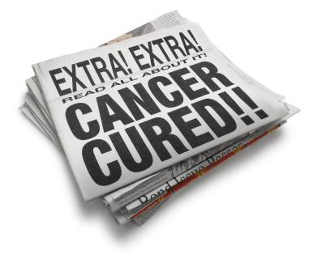
Activity Rules:
1.Each trial/surgery is one minute long.
2. Any cancer cells left at the end of the trial are doubled before the next round.
3.You beat cancer when all the cancer cells are gone. (BEAT)
4.You lose if the tumor becomes greater than 100 cells, or if you remove more than 10 healthy cells. (LOST)
5.If you just beat cancer, good job! Now, try again with a larger number of cancer cells.

Worksheet Directions:
Complete a row for each trial.
For the Outcomes, please write either “BEAT” or “LOST.”

Key:
Lima Beans: Cancer cells
Lentil beans: Healthy cells
Paper cup: Biomedical trash can
Trial | Starting number of cancer cells | Ending number of cancer cells | Starting number of healthy cells | Ending number of healthy cells | Outcome  (BEAT/LOST)
1 | 10

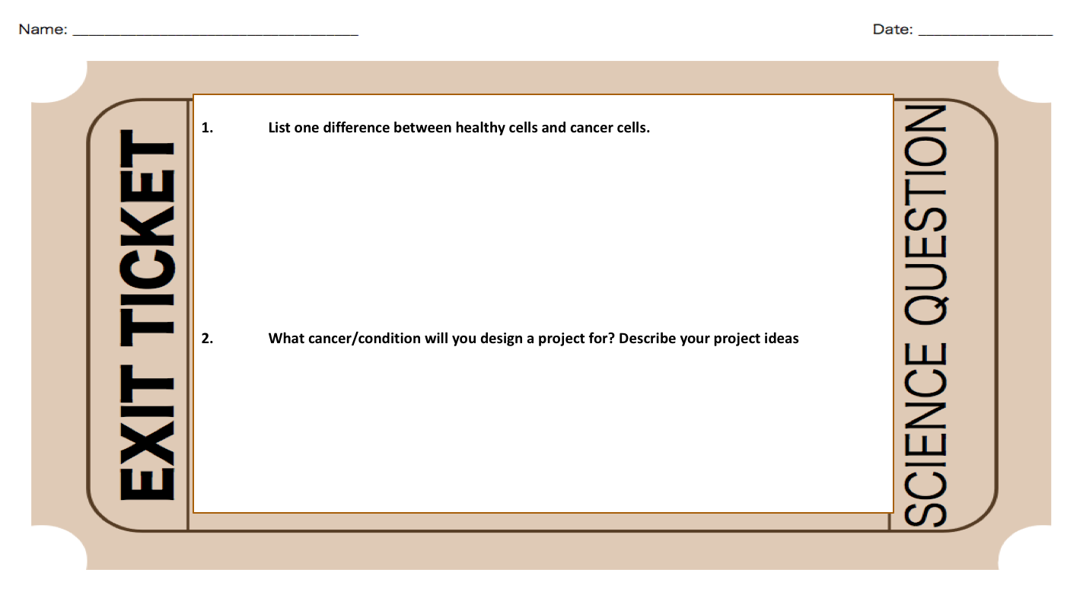Name_______________________ Period__________ Date______________
LE-A Awareness Campaign Project
This awareness project aims to empower you to step up and become positive role models for the school and community. You will become spokespersons for this vital issue and repeat community service activities as adults in the future. You will learn the importance and skill of mixing a festivity with something important of value.

- Review Rubric
- Select a cancer/condition which interests you
- Research the following:
-Condition name
-Brief overview of condition
-Treatment available
-Which body system is affected
3. Include:
-Research material (#2)
-An image/visual to represent
4. Select to design:
-A poster
-A “mock” event
-Awareness letter/ brochure

****Due 12/21****
Worth 2 quiz grades
