Name_______________________ Period__________ Date______________
Topic 2: Life Process Vocabulary Review
Match the correct term to the following definitions.
- Nutrition
- Reproduction
- Homeostasis
- Respiration
- Regulation
- Growth
- Development
- Transport
- Excretion
- Breathing
- Metabolism
- Obtain and use energy
- Respond to environment

_____1. A cheetah runs quickly through a field.
_____2. Digested food is brought to all the cells of a cat.
_____3. A plant is an autotroph and can make its own food.
_____4. A dog has a litter of 6 puppies.
_____5. A baby overtimes becomes an adult
_____6. Cells becomes larger in size or multiplies.
_____7. All living things use energy. How is energy made?
_____8. Cellular wastes are removed from an ameba.
_____9. A human maintains a normal body temperature of 37°C
_____10. A cat runs away quickly when it hears a loud noise.
_____11. All life processes working together.

Name_______________________ Period__________ Date______________

Topic 2: Stimulus and Response Review
Directions: Then decide what the stimulus and response is in each drawing. In addition, decide if the stimulus is external or internal.
1) 2) 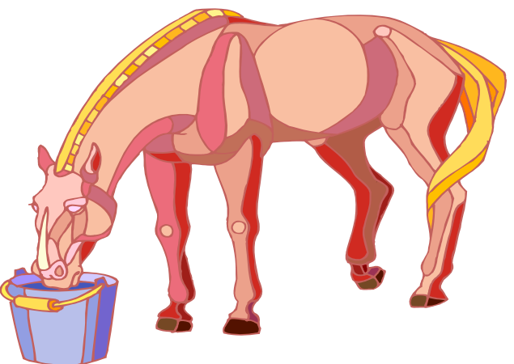

Stimulus: ____________________ Stimulus: _____________________

Response: ___________________ Response: _____________________

Stimulus: Internal or External Stimulus: Internal or External

3) 4) 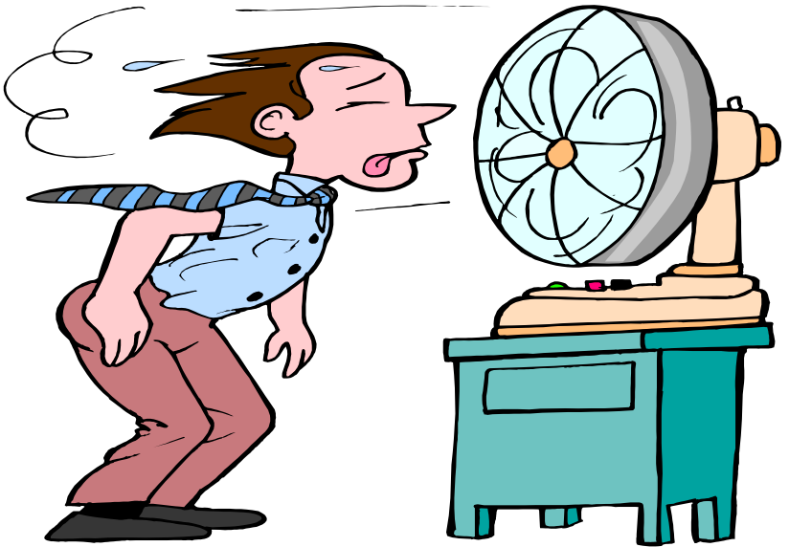

Stimulus: _________________ Stimulus: _____________________

Response: ________________ Response: _____________________

Stimulus: Internal or External Stimulus: Internal or External

Directions: Read the passages below. Then answer the questions that follow in complete sentences.

You are walking home from school one day when a large dog jumps out at you from behind a tree. He starts to growl and shows his teeth. You quickly turn around and walk in the opposite direction.

5) What was the stimulus in this situation? ________________________________________________________________
6) What was the response in this situation? _______________________________________________________________
7) Was the stimulus in this situation internal or external? ________________________________________________________________

You are at the mall walking through the food court on your way to buy a new CD. You smell fresh baked pizza and realize that you skipped lunch. You buy a piece of pizza and eat it before going to buy your CD.

8) What was the stimulus in this situation?
________________________________________________________________

9) What was the response in this situation?
________________________________________________________________

- Was the stimulus in this situation internal or external?
________________________________________________________________

Review Regents Questions

The diagram below represents two organisms.
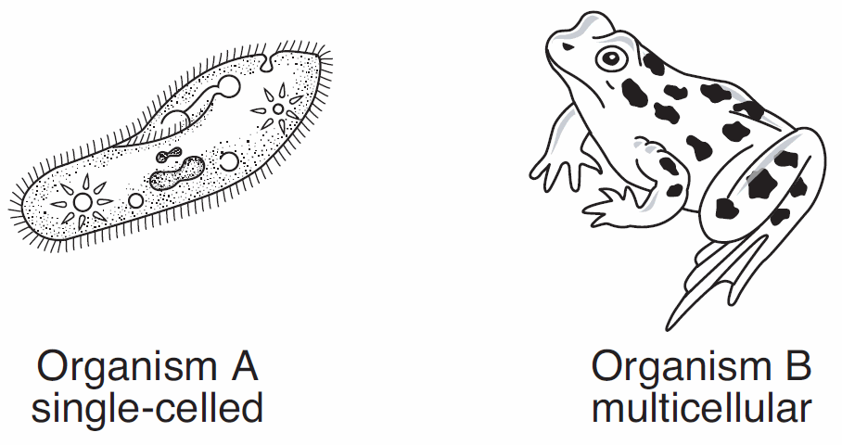
_____1. Which statement concerning organism A and organism B is correct?
- Organism A contains organs, whereas organism B lacks organs.
- Organism A and organism B have the same organ systems.
- Organism A and organism B both have structures that perform life processes.
- Organism A lacks structures that help maintain dynamic equilibrium.

_____2. Which life activity is not required for the survival of an individual organism
- Nutrition
- Respiration
- Reproduction
- Synthesis
______3. Small molecules are combined to form large molecules by the life function of
- Regulation
- Excretion
- Transport
- Synthesis

_____4. The absorption and distribution of materials within an organism is a life function known as
- Synthesis
- Reproduction
- Transport
- Locomotion

7. During which process is oxygen used by green plants?
- Photosynthesis
- Hydrolysis
- Osmosis
- Respiration

8. What is the chemical formula for glucose?
- H2O
- CO2
- C6H12O6
- CHO
9. Which life function is primarily involved in the conversion of the energy stored in organic molecules to a form directly usable by a cell?
- Absorption
- Circulation
- Digestion
- Respiration

10.When a planarian (a type of worm) is cut in half, each half usually grows back into a complete worm over time. This situation most closely resembles
- asexual reproduction of a single-celled organism
- sexual reproduction of a single-celled organism
- sexual reproduction of a multicellular organism
- asexual reproduction of a multicellular organism

- The removal of carbon dioxide and nitrogenous wastes from an organism illustrates the life function known as
- Regulation
- Nutrition
- Respiration
- excretion

- Which term is used to represent all of the physiological activities carried on by an organism?
- Regulation
- Metabolism
- Homeostasis
- Synthesis

- An organism develops active immunity as a result of
- manufacturing its own antigens
- producing antibodies in response to a vaccination
- receiving an injection of antibodies produced by another organism
- receiving an injection of a dilute glucose solution

15.List all life processes of a living thing below & describe the function
- ______________________________________________________________________________

- ______________________________________________________________________________

- ______________________________________________________________________________

- ______________________________________________________________________________

- ______________________________________________________________________________

- ______________________________________________________________________________

- ______________________________________________________________________________

- ______________________________________________________________________________

