Name_______________________ Period__________ Date______________

Bell Work: A. Processes of Life
The science of biology studies life and living things. Do you know what is meant by the term "life"? Scientists do not agree on one definition of life. They do agree, however, that the cells of living things (Organisms) carry on certain processes that are necessary for life. These processes or activities, common to all living things, are known as life functions. An organism is considered to be alive as long as its cell perform certain life functions. Nutrition, transport, respiration, excretion, regulation, growth, reproduction are life functions shared by living things. The total of all life functions required to sustain life is metabolism.

- The term "organism" is another word for _____________________________________________.

- List the life functions
_____________________________________________________________________________________________________________________________________________________________________________

B. Nutrition
Living things need food to supply energy for life activities and materials for the growth and repair of cells. During the life process of nutrition organisms obtain (get) and process food. Some organisms, such as green plants, can make their own food/sugars while other living things must obtain their food already formed. Organims that are able to make their own food are called autotrophs. Heterotrophs are organisms that are not able to make their own food.
Nutrition involves ingestion and digestion. Food is taken in from the environment by ingestion. Ingested food is not usually in a form that can be used by body cells and must be changed into a usable form. Digestion is the process that changes food into a form that can be used by the cell. During digestion large complex molecules are broken down into small simple molecules.
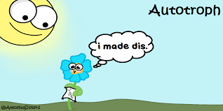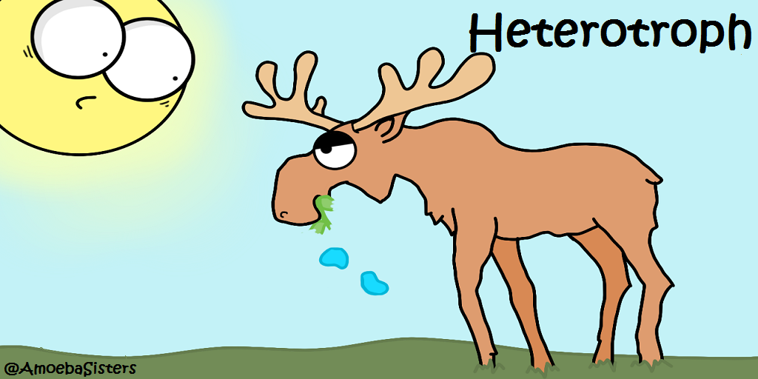

- The life activity responsible for obtaining and processing food is called _________________.

- What happens to food during ingestion? ___________________________________________________________________________

- What is digestion? _____________________________________________________.

- Explain why living things need food.
___________________________________________________________________________
___________________________________________________________________________

Name_______________________ Period__________ Date______________

Bell Work: C. Excretion

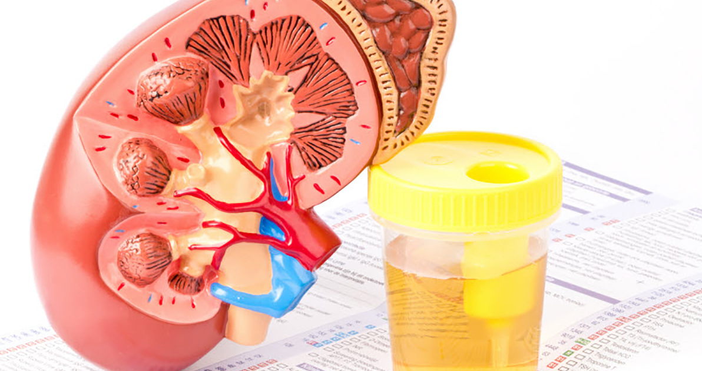
Life processes result in the formation of cellular wastes. These wastes are harmful to the organism and must be removed. Excretion is the removal of waste materials produced in the cells as a result of life activities. Products commonly excreted from cells are carbon dioxide and water.
Egestion is the process that removes undigested materials from the body. Do not confuse the process of egestion, which means to get rid of solid wastes, with excretion. Excretion is the elimination of gaseous or liquid wastes of cellular respiration.

- What is excretion?
______________________________________________________________________________________________________________________________________________________________________________
- Why is it necessary for an organism to remove wastes?
______________________________________________________________________________________________________________________________________________________________________________
- What is egestion the removal of?
______________________________________________________________________________________________________________________________________________________________________________
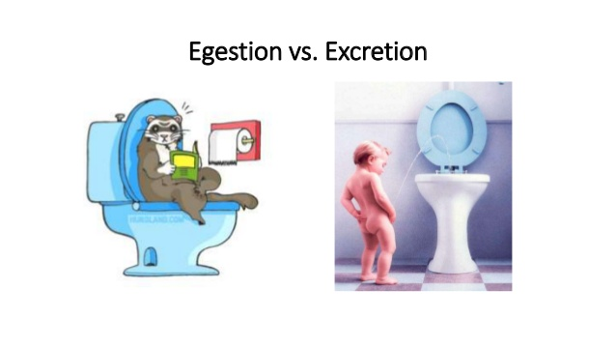

Name_______________________ Period__________ Date______________
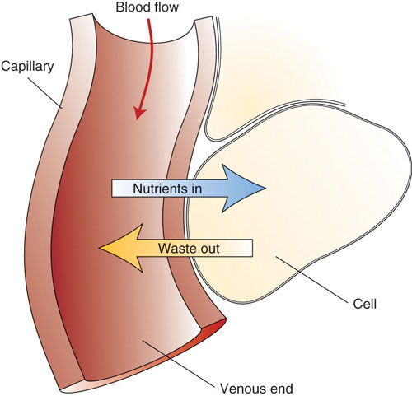
Bell Work: D. Transport
After digestion is completed nutrients, the parts of food that can be used by the cell, are carried to the cell. Transport is the life process that includes the ABSORPTION and CIRCULATION of materials throughout an organism. Absorption is the process by which the usable materials from food called the end products of digestion, as well as other dissolved materials, are taken into the cells, within cells, and/or throughout an organism. Along with nutrients, oxygen, water and wastes are also transported throughout a cell or organism.

- The usable parts of food are called_________________________________________.

- _______________ is the life process that includes the absorption and circulation of materials throughout an organism.

- What is circulation?
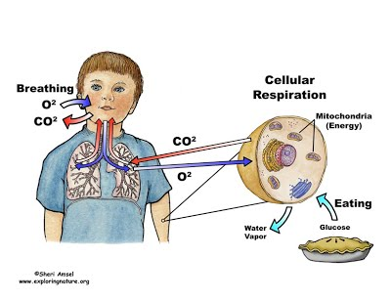
______________________________________________________________________________________________________________________________________________________________________________

E. Respiration
Living things need a constant supply of energy for their life activities. Respiration is a complex series of chemical reactions that release energy for life activities. An organism's energy is stored in food nutrients. Most organisms need oxygen for respiration – they are called aerobic organisms. A few organisms, known as anaerobic organism, do not need oxygen for their respiratory process.

- What do living things need?
______________________________________________________________________________________
- What is respiration?
______________________________________________________________________________________________________________________________________________________________________________
- What is the difference between aerobic and anaerobic organisms?
______________________________________________________________________________________________________________________________________________________________________________

Name_______________________ Period__________ Date______________

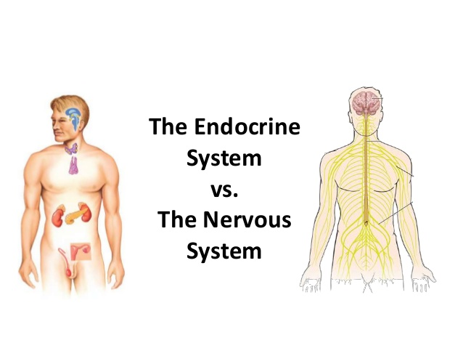
Bell Work: F. Regulation
The life activity responsible for the control and coordination of all the various activities of an organism is called regulation. The nervous and endocrine systems are responsible from regulation. Regulation allows organisms to respond to changes in the environment. This means they can find food, avoid danger, respond to light, and perform other tasks important to their survival. A change in the internal or external environment is known as a stimulus. Some examples of stimuli are light and temperature.

- Regulation is the life activity responsible for ____________________and _________________________.
- What is a stimulus?
______________________________________________________________________________________________________________________________________________________________________________3. What are two examples of stimuli?
______________________________________________________________________________________________________________________________________________________________________________

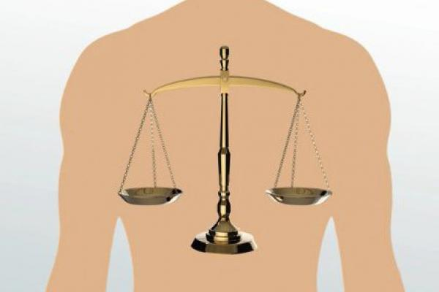
G. Homeostasis
The maintenance of a stable internal (inside) environment in spite of changes in the external (outside) environment is called homeostasis. When the organism is in homeostasis it is in a balanced or "steady" state. If there is a disruption in any organ system there may be a corresponding imbalance in homeostasis. Homeostasis in an organism is constantly threatened- if the organism's body fails to respond effectively, disease and/or death can occur. The metabolic processes are adjusting their function to help keep a balanced internal environment.

- What is homeostasis?
_____________________________________________________________________________________________________________________________________________________________________________

- What can happen is homeostasis is no longer present?
_____________________________________________________________________________________________________________________________________________________________________________

Name_______________________ Period__________ Date______________

Bell Work: H. Synthesis
Living things are able to produce complex substances from simpler substances by the process of synthesis. During this process the simpler food molecules produced during digestion are put together to make the complex materials needed by the organism. These complex materials become part of the structure of the organism. For example, during photosynthesis green plants "make" complex compounds (sugars) from simpler materials.
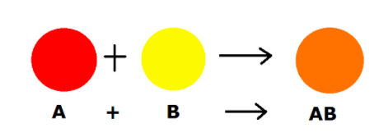

1.The process of synthesis makes_______________materials from _______________________ food molecules.
2. What happens to the materials that are synthesized by an organism?
______________________________________________________________________________________________________________________________________________________________________________

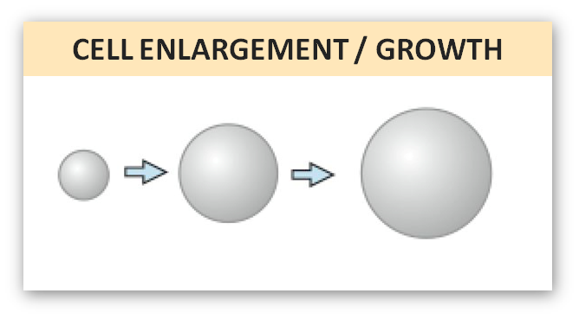
I. Growth
Growth results from synthesis. Growth is an increase in the size and/or number of cells of an organism. The complex materials produced during synthesis are used for growth. When cells grow, the size of the cytoplasm changes but not the size of the nucleus.

- Growth results from the complex materials produced during __________________________________.

- Compare the changes in the size of the cytoplasm and the size of the nucleus that occurs as result of growth.

3. An increase in the size or number of cells in an organism is called _______________________________

Name_______________________ Period__________ Date______________

Bell Work: J. Reproduction
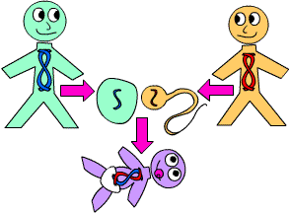
Reproduction is the production (making) of new organism. This is the only life process that is not necessary for the life of an individual organism. It is, however, necessary for the continued existence of a particular group of organisms. For example, one cat can live a normal life without reproducing, but if all cats stopped reproducing, the group of organisms called cats would become extinct.
Cells reproduce by cell division- one cell divides into two cells. Cell division involves a series or changes in the cell leading to the production of two new cells. In organisms made up of many cells, multicellular, the production of new cells also results in the growth and repair of damaged tissues.

- Do organisms need to reproduce to stay alive?
_______________________________________________________________________________________
- If an organism didn’t reproduce what would happen?
_______________________________________________________________________________________
- What process do cells reproduce by?
_______________________________________________________________________________________

