Name_________________ Period__________ Date___________________
Lab: Using a Dichotomous Key to Identify Primates

Why is it important to classify things?

You may be wondering why you should care about taxonomy, which is the scientific study how living things are classified. Classification is the process of grouping things based on their similarities. Classification is very important in science because it helps organize living things into groups so it becomes easier to study them.

What is a Dichotomous Key?

A dichotomous key is a guide of paired statements that help classify and identify living organisms. It is one of the most useful tools available to a scientist trying to identify an organism. By reading the statements in the taxonomic key you can begin to identify the object based on its physical characteristics. By using their physical characteristics that are easily observed to make an accurate identification of the organism.

Directions to Identify Primates

- You will be given 12 pictures of various primate animals. You will use the dichotomous key to identify each one.
- Observe each picture of organisms carefully.
- Read the paired statements in each of the boxes (1-11) and decide which of the statements applies to the organism you are trying to identify.
- Follow the directions in the right-hand column to lead you to your next choices.
- Continue making choices until you reach the name of the primate.

Name of Primate | Name of Primate
Primate 1: | Primate 7:
Primate 2: | Primate 8:
Primate 3: | Primate 9:
Primate 4: | Primate 10:
Primate 5: | Primate 11:
Primate 6: | Primate12:

Primate Taxonomic Key
1 | No tails | Go to line 2
 | Have Tails | Go to line 4
2 | Animal stays mostly on ground | Gorilla
 | Animal stays mostly in trees | Go to line 3
3 | Has long, red fur | Orangutan
 | Has short, dark fur | Chimpanzee
4 | Eyes are very large compared to size of the head | Go to line 5
 | Eyes are small compared to size of the head | Go to line 6
5 | Pointed Ears | Mouse lemur
 | Rounded Ears | Fat-tailed lemur
6 | Elongated (long) nose | Go to line 7
 | Normal nose | Go to line 8
7 | Reddish, fleshy nose | Proboscis monkey
 | Grey, firm nose | Baboon
8 | Has stripes | Go to line 9
 | Does not have stripes | Go to line 10
9 | Has stripes down the head | Fork-marked lemur
 | Has a striped tail | Ring-tailed lemur
10 | Has a mane like a lion | Tamarin
 | Does not have a mane like a lion | Go to 11
11 | Large ears, rounded at tips | Aye Aye
 | Large ears that are pointed | Squirrel monkey
1
4
3
2
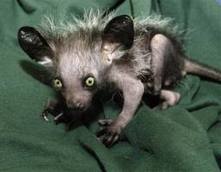
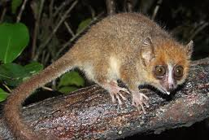
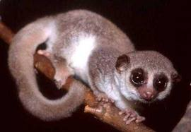
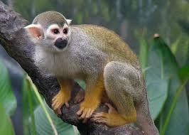
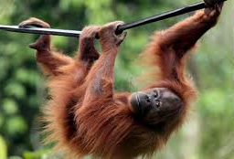
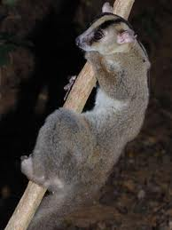
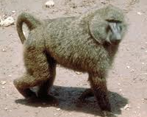
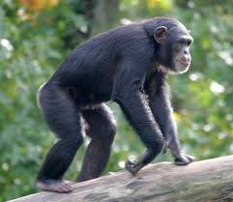
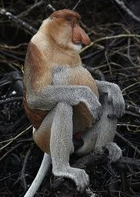
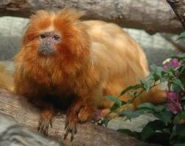
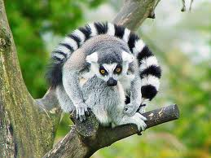
5
6
7
8
12
11
10
9

- Why is it important to classify living organisms? .

- Explain why are physical features most often used when using a dichotomous key? .

- Trees are usually identified by their leaves. List two ways that a tree might be classified and identified in the winter when they have no leaves.

- Suppose you visited a large birdhouse at the zoo. List two characteristics you could use to classify the different types of birds.

Part B: Construct a Dichotomous key
- Examine the group of items your teacher gives you. List some characteristics you could use to classify these items into groups.
Ex. Smaller than 1 cm or Larger than 1 cm.
- Using the dichotomous key from part A as a model, construct a key for your group of items. Make sure that each of the paired statements in your key are opposites.
- Once your dichotomous key is complete give it a title , test it with each item and revise your key if necessary.
- Exchange keys with another group to identify items. You may give suggestions
______________________Dichotomous Key

