Name_________________ Period__________ Date___________________

Lab: The Euglena
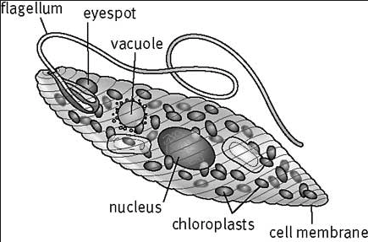
Purpose: To study the euglena which is classified in the Protista kingdom. The euglena is a unicellular organism capable of maintaining life with a minimum of organelles (specialized structures within a living cell).

Pre-Lab:
Euglena is typically a green color and is a type of algae. It is considered to be a plant-like protist due to producing food/energy, but it is not considered to be in the plant kingdom because it also consumes food and is unicellular. Euglena can act as an autotroph or heterotroph.

- Why isn’t Euglena considered a plant?
_____________________________________________________________

Euglena is a unicellular organism that moves by using its flagella. Flagella are whip like structures which allows the euglena to move. Euglena actually has 2 flagella but one is short and the other we can typically see is long.

- Describe the function of flagella.
_______________________________________________________________

Euglena is plant like because it has chloroplasts which is why usually they are a green color. Chloroplasts are small organelles inside the cells. They absorb light to make sugar in a process called photosynthesis. Chloroplasts contain the molecule chlorophyll, which absorbs sunlight for photosynthesis. Photosynthesis is the process by autotrophs make food. It is a chemical process that uses sunlight to turn carbon dioxide into sugars the cell can use as energy.

- Describe chloroplasts.
_______________________________________________________________

- What is the function of photosynthesis?
_______________________________________________________________

Euglena is typically found in ponds and lakes. They are excellent swimmers and they have an eyespot/stigma which helps them locate sunshine for the process of photosynthesis.

- Why is the eyespot important for euglena?
_______________________________________________________________

Euglenas reproduce by simply splitting in two, just like amoebas and paramecium. This is a form of asexual reproduction and is called binary fission.

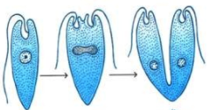
- What is asexual reproduction?
_______________________________________________________________

- What is binary fission?
_______________________________________________________________

Lab Activity
Materials:
Euglena prepared slide & microscope

- Examine the euglena slide under low power (40x).
- Locate the euglena, which is sometimes a green color.
- Once focused and centered go to medium power (100x).
- Go to high power (400x) and observe the specimen (euglena).
- Make 3 drawings of the euglena moving at 3 minute intervals in the spaces provided.
- Use arrows to indicate the flow of the cytoplasm in the euglena.
- Label: the nucleus and flagella.
Time | Total Magnification  (Ocular lens x Objective) | Observations
0 minutes
3 minutes
6 minutes

- What kingdom does the euglena belong to?
_____________________________________________________
- How does the euglena obtain food/energy?
_____________________________________________________
- What cell type does euglena have, Prokaryotic/ Eukaryotic?
_____________________________________________________
- Is euglena unicellular or multicellular?
_____________________________________________________
- Describe how euglena moves or accomplish locomotion.
_____________________________________________________
- Where is euglena typically found?
_____________________________________________________
- What is the function of the eyespot/stigma?
_____________________________________________________
- How does the flagella reproduce?
_____________________________________________________

- Why are algae like euglena not grouped in the plant kingdom?
_____________________________________________________

Label the euglena below
- Flagella
- Eyespot/Stigma
- Nucleus
- Chloroplast
- Cell membrane
