Name_________________ Period__________ Date___________________
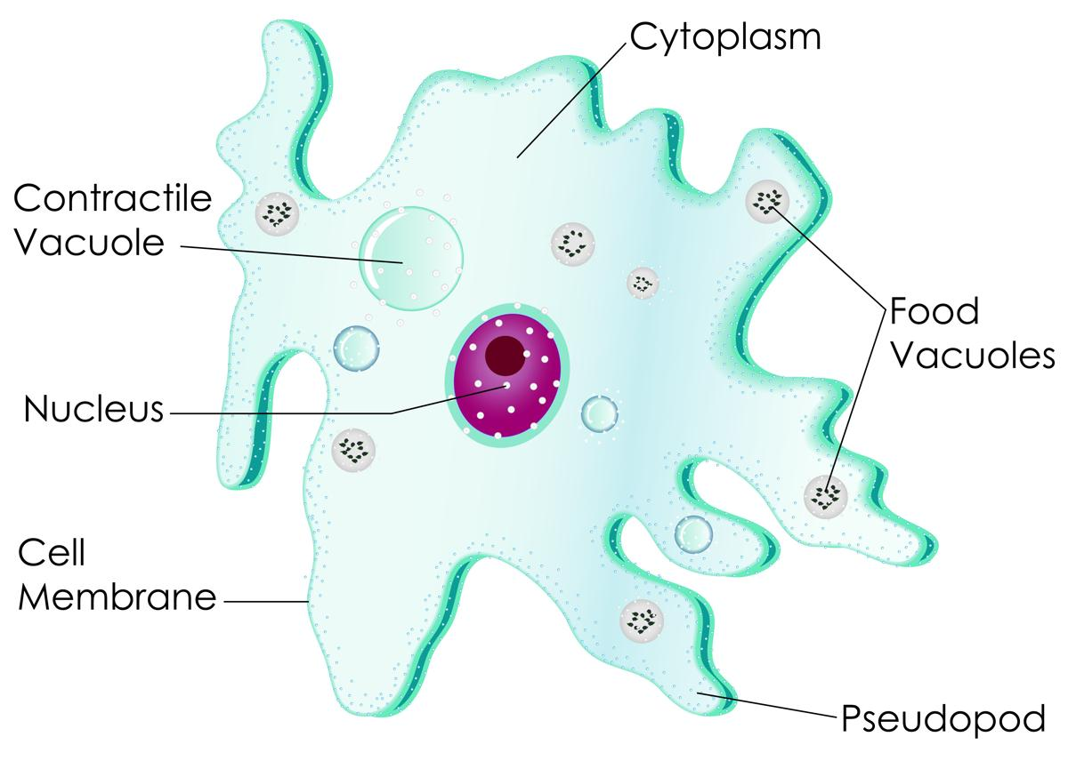

Lab: The Amoeba
Purpose: To study the amoeba which is classified in the Protista kingdom. The amoeba is a unicellular organism capable of maintaining life with a minimum of organelles (specialized structures within a living cell).

Pre-Lab:
Wherever you find water like ponds, lakes or streams, you will probably find a unicellular organism which belongs to the kingdom called protists. A protist is an organism that is made up of only one cell.

- Where are protists found?
_______________________________________________________________

- What is a protist?
_______________________________________________________________
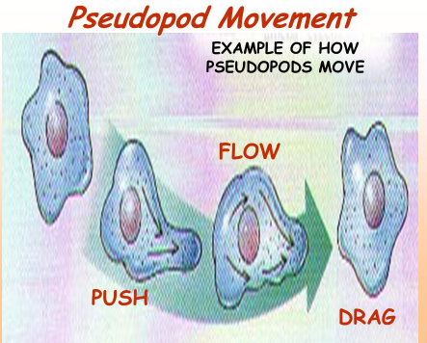
The amoeba is one of the many kinds of protists. It is an animal- like protist called a protozoa. An amoeba is an irregular shaped protist that moves by creating Pseudopods. When the amoeba moves, its cytoplasm(fluid material within the cell) streams forward, pushing against the cell membrane and produces pseudopods. The amoeba moves VERY slowly.

- What is a protozoa?
_______________________________________________________________

- Describe an amoeba’s locomotion/movement.
_______________________________________________________________

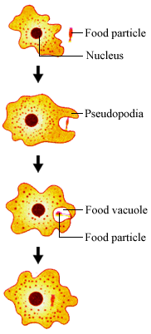
The amoeba is a heterotroph. It must obtain food for nutrition and energy. The amoeba eats algae, bacteria, plant cells and smaller unicellular organisms. The amoeba uses its pseudopods to obtain food for the required energy. The pseudopods surround the food and the amoeba will engulf the food. Engulf means to swallow whole. This process is called Phagocytosis. The food id then stored in a food vacuole where it will be digested.

- How does the amoeba obtain food?
__________________________________________

- What does an amoeba eat?
___________________________________________

The amoeba has a nucleus, which acts like its brain. It controls everything the amoeba does. It also has a contractile vacuole for removing excess water that builds up inside the amoeba.

- What does the nucleus do in an amoeba?
___________________________________________

- Describe the function of the contractile vacuole.

___________________________________________

Lab Activity
Materials:
Amoeba prepared slide & microscope

- Examine the amoeba slide under low power (40x).
- Locate the amoeba, which is a grey color.
- Once focused and centered go to medium power (100x).
- Go to high power (400x) and observe the specimen (Amoeba).
- Make 3 drawings of the amoeba moving at 3 minute intervals in the spaces provided.
- Use arrows to indicate the flow of the cytoplasm in the amoeba.
- Label: the nucleus and pseudopods.
Time | Total Magnification  (Ocular lens x Objective) | Observations
0 minutes
3 minutes
6 minutes

- What kingdom does the amoeba belong to?
_____________________________________________________
- How does the amoeba obtain food/energy?
_____________________________________________________
- What cell type does an amoeba have, Prokaryotic/ Eukaryotic?
_____________________________________________________
- Is an amoeba unicellular or multicellular?
_____________________________________________________
- Describe how an amoeba moves.
_____________________________________________________
- Where is an amoeba typically found?
_____________________________________________________
- What is the function of the contractile vacuole?
_____________________________________________________
- What energy source is an amoeba, an autotroph or heterotrophic? Explain.
______________________________________________________________________________________________________________________________

Label the amoeba below
- Nucleus
- Cytoplasm
- Food vacuole
- Pseudopods
- Cell membrane
- Contractile vacuole
- Food being engulfed by pseudopods

