Name___________________________ Period__________ Date___________________

Lab: Elodea Plant Cells
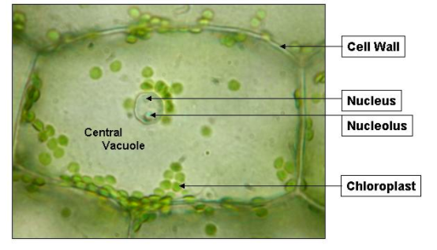
Purpose:
To use a compound microscope to make observations about the plant cells from an elodea leaf in order to become familiar with the structure and function of plant cells.

Plant Cells:
Today we will be looking specifically plant cells of an elodea leaf. Plant cells have various organelles but the ones we will be able to observe in the lab are the Chloroplasts, Cytoplasm, Cell Wall, Nucleus and Vacuole.

The nucleus directs the cells activities. The cytoplasm supports and protects cell’s organelles and also provides some nutrients for cell. The cell wall supports structure of the cell and also protects. Chloroplasts are numerous green bodies which contains green chlorophyll for photosynthesis to make sugars for food. The vacuole is a storage center for food, wastes and proteins. In plant cells, the vacuoles are larger in size than an animal’s cell vacuole. The chloroplast and cell wall are only found in plant cells and not in animal cells.
- What is the function of chloroplasts?
___________________________________________________________________________
- Name two structures found in plant cells but not animal cells.
___________________________________________________________________________
- Name three structures found in plant cells AND in animal cells.
___________________________________________________________________________
- What structure surrounds the cell membrane (in plants) and gives the cell support.
___________________________________________________________________________
Elodea Plant:
Elodea is an aquatic plant and has a nickname of the waterweed. It can be found in freshwater ponds, marshes, lakes and streams.
- Where can Elodea be found?
___________________________________________________________________________
Cyclosis:
Cyclosis streaming is the movement of the fluid cytoplasm within a plant or animal cell. The motion transports and circulates the cell’s nutrients, proteins, and organelles within cells.
- Are the chloroplasts moving themselves?
___________________________________________________________________________
Staining a Cell:
Since cells are mostly transparent, or clear, it is necessary to stain them a certain color in order to see them under a microscope. In order to see the nucleus of a cell during today’s lab we will be using a stain so that it shows up under a microscope Lugol’s iodine.

- Why do we use Lugol’s Iodine when observing elodea cells (plant cells)?

___________________________________________________________________________
Procedure:
Directions: Check off each step as you complete it.
- 1. Place a drop of water on a clean slide.
- 2. Break off a small leaf from the tip of an elodea plant.
- 3. With forceps place the leaf in drop of water on the slide.
- 4. Add a coverslip.
- Observe under LOW power.

- What is the shape of the plant cells?
___________________________________________________________________________
- 7. Observe under HIGH power.

- Describe the shape and location of the chloroplasts.
___________________________________________________________________________
- How are the chloroplasts moving in a cell? (If they aren’t warm the slide in your hand under bright light.)
___________________________________________________________________________

- 10. Indicate which power you are viewing and draw what you see in the circle below marked HIGH Power.

Make sure to label the
  - Cell Wall
  - Chloroplasts
  - Any of structures you see

Total Magnification  (Ocular lens x Objective) | ELODEA CELL  Observations

- 11. Break off another leaf and place it in a drop of Lugol’s iodine on a clean slide.
- 12. Add a cover slip.
- 13. Focus until clear.
- 14. Indicate which power you are viewing and draw what you see in the circle below.
Make sure to label the
  - Cell Wall
  - Chloroplasts
  - Nucleus
  - Nucleolus
  - Large Vacuole

Total Magnification  (Ocular lens x Objective) | ELODEA CELL  Observations

- What structures did the elodea plant cell have in common with the human cheek cell?
______________________________________________________________________________
- How do elodea and cheek cells differ?
______________________________________________________________________________
- Chloroplasts cannot move on their own. How do you think they move around the cell?
______________________________________________________________________________
- What structures were you able to see more clearly after staining the elodea?
______________________________________________________________________________
- What is the shape of a plant cell?
______________________________________________________________________________

