Name___________________________ Period__________ Date___________________

LE Bell Work: The Cell and Human Body Systems
The organelles found inside the cell can be compared to various human body systems. For example, the nucleus of the cell controls the cell. The human brain controls the activities of the human. The brain belongs to the nervous system. Therefore, the nucleus can be compared to the nervous system.

Complete the following chart:

Body Systems Function Organelle
- Nervous System Controls everything Nucleus
- Digestive System
- Circulatory System
- Excretory System
- Respiratory System
- Skeletal System

Name___________________________ Period__________ Date___________________

Partner_______________________________________________________________________

LE Incredible Edible Cell
Purpose: You will use several different food items representing the various organelles or cell structures found in plant and animal cells to construct an edible cell model. This activity will help you learn more about the different parts of a cell and their functions.

Background: All cells have a cell membrane, which forms a barrier to separate the cell from its environment. The cell membrane surrounds a gel-like fluid called cytoplasm, which is the medium that holds all the organelles of the cell. The large nucleus of a cell is similar to your brain because it functions as the cell’s control center. The nucleus contains genetic material that is used as instructions for directing cell functions. Endoplasmic reticulum (ER) surrounds the nucleus and helps to form and move proteins throughout the cell. Attached to the ER are ribosomes, which produce proteins and can also be found floating elsewhere in the cytoplasm. The golgi body receives materials from the ER and packages them for transport to other parts of the cell. The “powerhouses” of the cell are the mitochondria, which convert food energy to usable energy. Water, food, and other materials are stored in vacuoles. Lysosomes are the clean-up crew of the cell- they contain chemicals that break down old cell parts so they can be used again.

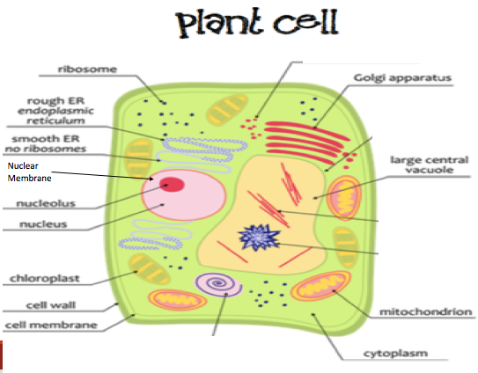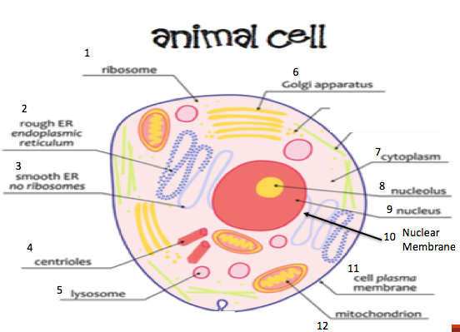

Procedures:
Do NOT eat any of the materials until given permission by your instructor!! Use gloves when handling food items!

1. Label the edge of a paper plate with your group name and cell type (animal or plant).
2. Spread frosting evenly over the base to represent the cytoplasm.
3. Assemble your model by sticking the appropriate “organelles” into the “cytoplasm,” showing correct spatial relationships between different types of organelles.
5. Complete Table 1 into your lab notebook, completing the table by filling in the main function of each organelle.
***Use a textbook and your notes as references! ***
Cell Chosen (Animal or Plant) __________________________________
Organelle (Cell Part) | Candy Chosen | Why did you choose this candy? | Function of Organelle
Cell Wall (Plant Cell)
Or
Centrioles (Animal Cell)

Cell Membrane

Nucleus

Cytoplasm

Mitochondria

Chloroplasts (Plant only)

Endoplasmic Reticulum
Ribosomes

Golgi Bodies

Vacuole

Lysosomes

Nuclear Membrane

Nucleolus

Other

