Name___________________________ Period__________ Date___________________

LE Cell Topic 8: Cell Membrane

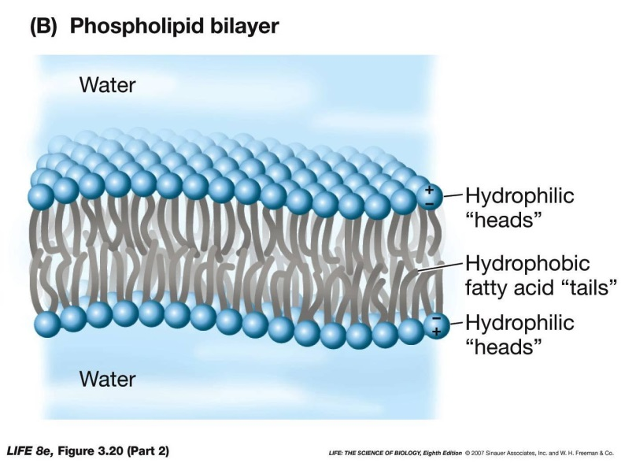
- Cell Membrane:
- Also called the _________________________________
- Separates the cell from its external environment
- Controls the movement of materials into and out of the cell
- Makes it possible for the cell to be different from its surrounding environment
- Keeps the internal conditions of the cell constant
Bi-Lipid Layer:
- A Two-Layered Structure
Semi-Permeable Membrane or Selectively Permeable:
  - Some substances can pass through easily, other substances can only pass through to some slight extent or at certain times, and some substances cannot pass through at all
 | Part | Function
A. | Lipid
B. |  | Involved in cross-membrane transport
C. | Receptors

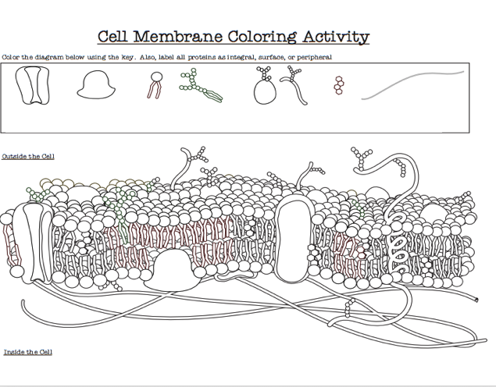
Name___________________________ Period__________ Date___________________

LE Daily Quiz Cell Membrane

Match the Cell Membrane Term with Function
- Lipids
- Proteins
- Receptors
- Cell Membrane
- Semipermeable
- Hydrophobic Tail
- Hydrophilic Head
- Bi-Lipid Layer

- Water hating (Inside of the Bi-lipid layer)
- Separates the cell from its surrounding environment. Controls the movement of materials into and out of the cell
- Two-layer structure
- Allowing certain substances to pass through it but not others
- Make a semi-permeable barrier between the cell and its environment.
- Involved in cross-membrane transport
- Hormones may bind to them for a response within the cell.
- Water loving lipid (outside of the Bi-lipid layer)

