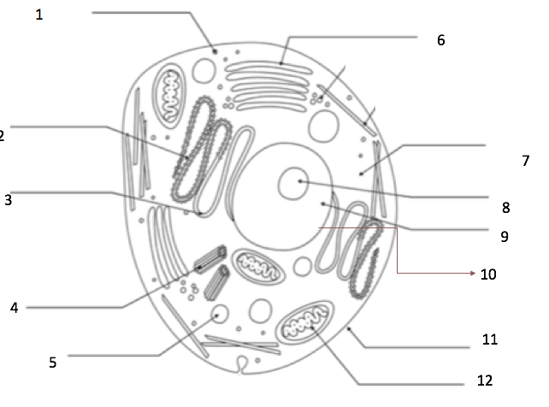

Cell Membrane | Cytoplasm | Nuclear Membrane
Mitochondria | Ribosomes | Nucleolus
Smooth Endoplasmic Reticulum (E.R) | Golgi Bodies | Vacuoles
Rough Endoplasmic Reticulum (E.R) | Lysosomes | Centrioles

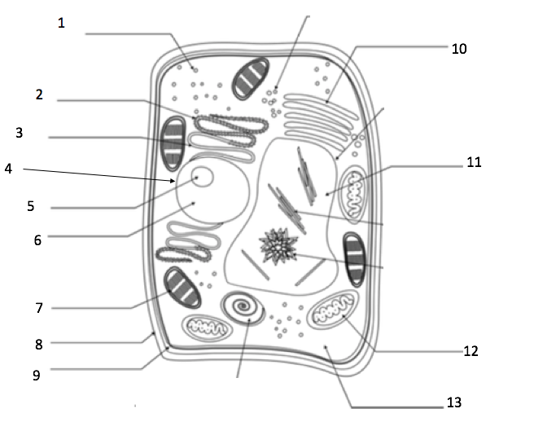
Cell Membrane | Nuclear Membrane | Nucleolus | Nucleus | Golgi Body
Cell Wall | Smooth E.R | Ribosome | Cytoplasm
Chloroplast | Rough E.R | Vacuole | Mitochondria

Cell Matching Answer Sheet

Term | Function | Drawing
- Cell Membrane
- Chloroplast
- Nucleus
- Mitochondria
- Endoplasmic Reticulum
- Cytoplasm
- Nuclear Membrane
- Ribosome
- Golgi apparatus/body
- Cell Wall
- Lysosome
- Organelle
- Levels of Organization
- Cell Theory

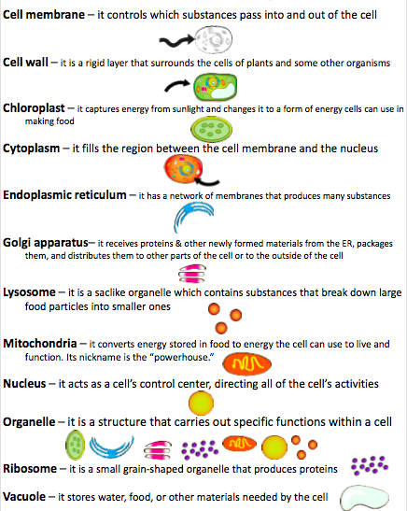
Cell Theory- All organisms are made of 1 or more cells. Cells are basic building blocks of life All cells come from existing cells.

Levels of Organization- Organelles, Cells, Tissues, Organs, Organ System, Organism

