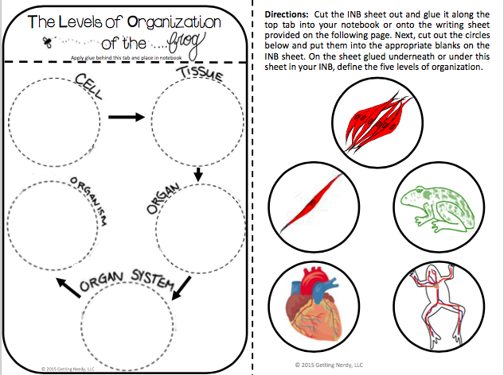

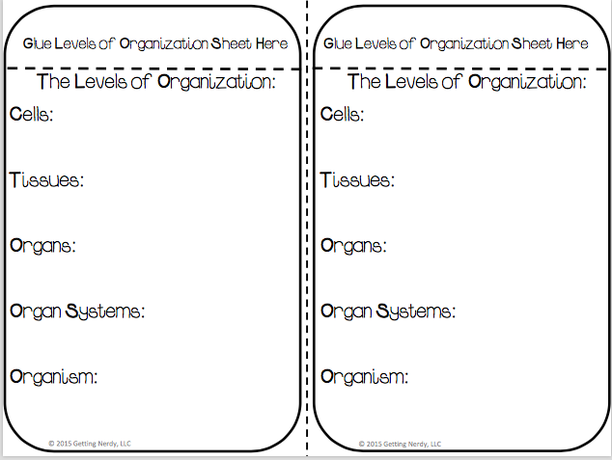
Name_____________________________ Period__________ Date___________________

- There are three parts to the cell theory:
- All living things are_____________________________________________________
- Cells are the __________________________________________________________
- Cells come from _______________________________________________________
- There are 5 Kingdoms of life:
- ____________________________ 4.__________________________________
- ____________________________ 5.__________________________________
- ____________________________
- Structures used for locomotion for Protista
- Euglena = _________________________
- Paramecium= ______________________
- Amoeba= __________________________
Cell Topic 2: Levels of Tissue Organization
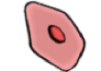  Cell | 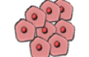  Tissue | 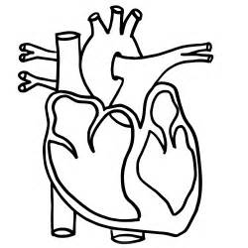  Organ | 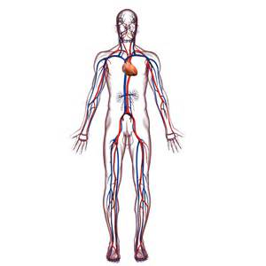  Organ System | Organism

- Cell: Smallest working unit of life that serves a _________________________________.
- Least complex level

- Tissue: Made of several _____________similar in structure and function that work together to perform a specific job.

- Organ: Made of similar _________________that work together to perform a specific activity.

- Organ System: Groups of one or more organs working together to perform functions for the organism.

- Organism: __________________Living thing that carries out all basic life functions.
- Most complex level of organization

Levels of Organization

- Cell
- Organ
- Organism
- Tissue
- Organ System

Name_____________________________ Period__________ Date___________________

LE Cells Daily Quiz 2
- What was the name of today’s topic? ___________________________________________________

- Complete the diagram below from least complexity at the top to most complex towards the bottom.
Cell | Organ | Organism | Tissue | Organ System

Name_____________________________ Period__________ Date___________________

LE Cells Daily Quiz 2

- What was the name of today’s topic? ___________________________________________________

- Complete the diagram below from least complexity at the top to most complex towards the bottom.
Cell | Organ | Organism | Tissue | Organ System

