Name___________________________ Period__________ Date___________________
Cell Topic 1-4 Quiz
Match each organelle with correct function. Write answers in the spaces provided below.
- Chloroplast
- Cell Membrane
- Nucleus
- Mitochondria
- E.R
- Cytoplasm
- Nuclear Membrane
- Ribosome
- Golgi Body

- Makes Protein
- Surrounds the nucleus and offers protection. Decides what goes in & out of the nucleus.
- Supports and protects cell parts. Provides some nutrients.
- Packages and transports proteins.
- Power-house of the cell. Breaks down sugars for energy.
- Controls all cell activity.
- Barrier that surrounds the cell. Protects cell and decides what comes in and out of cell.
- Makes food for photosynthesis.
- Carries proteins and other materials from one part of the cell to another. Has a rough and smooth. Located close to the nucleus.

- The diagram below represents levels of organization in living things.
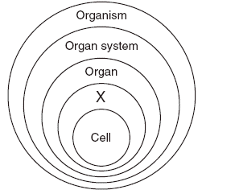
Which term would best represent “X”?
- Human
- Tissue
- Stomach
- organelle

