Name___________________________ Period__________ Date___________________

LE Cell Membrane Functions

Functions
A.Protection | Isolates and protects the inside of the cell.  - Cells internal environment has to remain constant  - pH and concentrations of cell substances must remain constant  - Maintain homeostasis  - Maintenance of cell homeostasis a result of the cell membranes properties
B.Cell Communication | - Ways:  - ______________: Hormones are specific. Molecules travel from a signaling cell to a target cell through the blood stream  - ______________: Message travels from one cell to another through nerve signals.
C.Controls what goes in/out | Semi-permeable (Like a screen)  - Certain substances pass through the cell membrane more easily than others.  - Substances that pass through more easily: Lipids, alcohols, water, glucose, amino acids., CO₂, O₂  - Substances that can’t pass through easily: Proteins and starches  2 Types of Transport  - ____________ Transportation  - Active Transportation  - Passive:  - Ex: Diffusion & Osmosis  - Travels from HIGH to LOW  - No ATP required  Diffusion: Molecules tend to spread from a region of higher concentration to lower concentration  Osmosis: Movement of water from high to low concentrations of WATER through a semipermeable membrane!  - Active:  - Ex: Phagocytosis  - Travels from LOW to HIGH  - ATP Required (Energy is used)

B: Cell Communication: Hormones

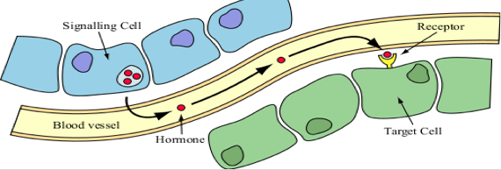

- Hormones are specific (They travel to a specific target cell for a cell response)
- Molecules travel from a signaling cell to a target cell through the blood stream

B: Cell Communication: Neurotransmitters
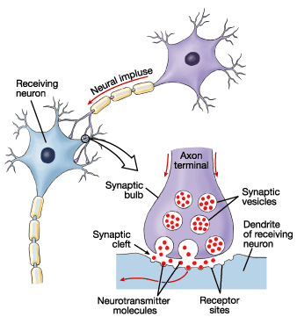
- A Neuron is a type of cell
- A chemical message travels from one neuron to another through a nerve signal

C. Controls what comes in and out of cell
Passive vs Active Transportation
Passive Transportation | Active Transportation
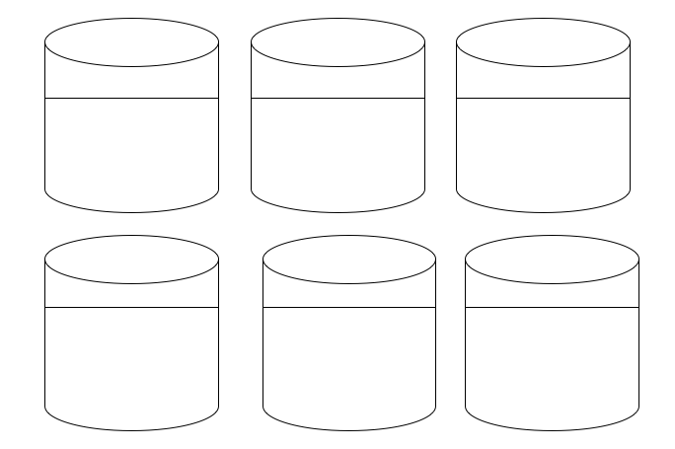
Passive Transport
Diffusion:
Colored Dye Movement

Osmosis: Solution Types
Isotonic: same concentration in and out of cell of WATER  ISO=Same | Hypotonic: low concentration in the cell… HIGH Outside  water concentration  Hypo= “Hipo”large animal | Hypertonic: high concentration in the cell… LOW outside  water concentration  Hyper= child will lose calories and “shrink”
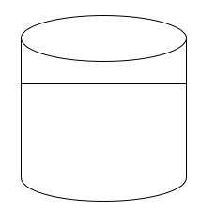

Active Transportation:
Phagocytosis

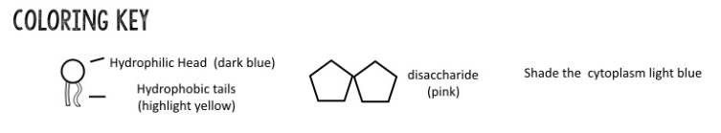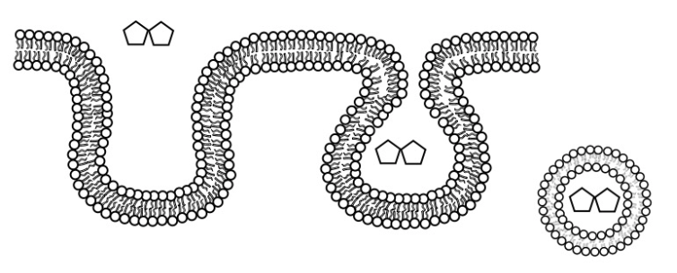

Name___________________________ Period__________ Date___________________

LE Cells Daily Quiz

- There are 3 functions of the cell membrane, list two.

- What are the two ways cell communicate?

- Does Active Transport require ATP?

- Name the solution type and the resulting change to the red blood cell in the tube using the provided word bank.
Cell stays the same. | Water moved into cell (Cell bursting) | Isotonic
Water moved out of cell (Cell shrinking) | Hypotonic | Hypertonic

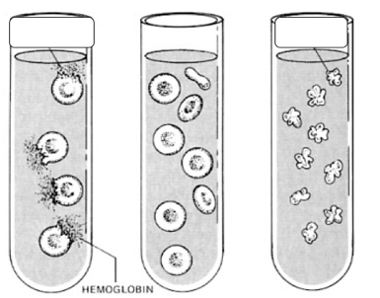

Solution Type: ______________________ _____________________ __________________________
Cell Change: _______________________ _______________________ __________________________

