Name___________________________ Period__________ Date___________________

LE A Cell Topic 3: Parts of a Cell
Many of the world’s organisms are made of only one cell, but all organisms from the most basic to the most complex are all made of cells. Cells are like a miniature city surrounded by a membrane that keeps the interior operating within its normal range (at homeostasis).

Despite the simple idea created above there is a level of coordination that is almost impossible to imagine. All of the cells organelles (little organs) are working with each other at all times to keep the balance.

The cell membrane acts as selective barrier between the interior and exterior of the cell. This membrane contains a jellylike substance called cytoplasm. This material helps support and suspends the organelles throughout the cell. Organelles have a large range of size, shape and function. Organelles are responsible for transporting materials, extracting energy from nutrients, protein synthesis, dispose of waste, and store information.

To be considered alive and a cell or a more complex multicellular organism it needs to complete all eight life functions. Everything from bacteria to humans are constantly maintaining the balance of life. All living things use energy to grow and develop. These activities require many chemical reactions which is called metabolism.

Questions
- Describe the role that each job has below.
Mayor Fireman
Police Sanitation
Trucking Construction
Power Plant Farmer
- What role does cytoplasm play in the cell?
- What does the term organelle refer to?
- Name 3 functions of the organelles.

- What is metabolism?

What are the organelles found in both plant and animal cells?
Diagram | Organelle | Function | Analogy
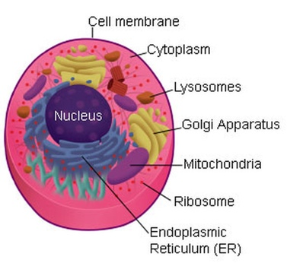 |  | Determines what goes in/out of the cell.  Protects and supports the cell.
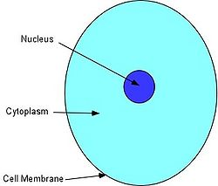 |  | The watery material in the cell between the cell membrane and the nucleus  The place where many chemical reactions occur
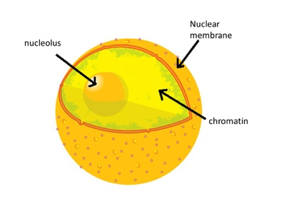 |  | Decides what goes into and out of the nucleus.
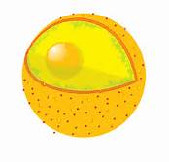 |  | Is the control center of the cell.  The “brain” of the cell.  Stores the genetic material of the cell, called DNA.

Name___________________________ Period__________ Date___________________
LE-A Cells Daily Quiz 3
- What are organelles?

- Why is a cell like a city?

- Pick ONE organelle we learned today and explain its function: Cell membrane, Cytoplasm, Nuclear Membrane or Nucleus

- What is metabolism?

