Name___________________________________________ Period__________ Date___________

**LE-A Bell Work Topic: Naming & Sequence of Classification**

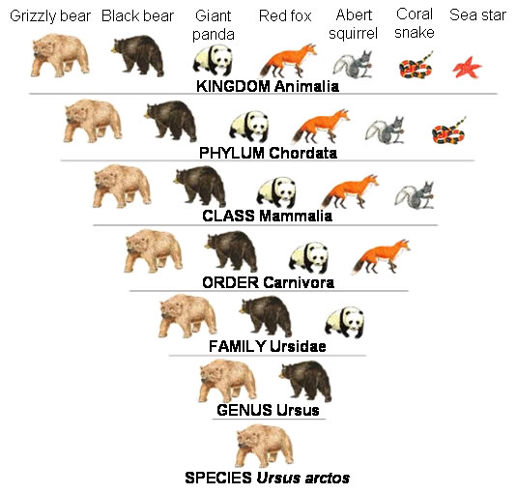

The **naming** of life began with the work of Carolus Linnaeus; we call this branch of biology *taxonomy*. Linnaeus improved earlier taxonomist’s work (of two kingdoms) and expanded it to five kingdoms which is the accepted modern taxonomy. We now use the following system for classification of living organisms:

Kingdom 🡺 Phylum 🡺 Class 🡺 Order 🡺 Family 🡺 Genus 🡺 Species

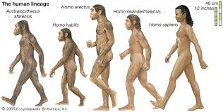

Linnaeus also introduced the *binomial nomenclature*, **a two-word Latin based naming method derived from GENUS and SPECIES**. His concept is based on a last and first name system, directly related siblings share a common last name with a specific name as a first name. The naming system is also based on a visible trait or location that the species is found.

1. How did the work of Linnaeus improve the field of taxonomy?  
   ___________________________________________________________________________________  
   ___________________________________________________________________________________
2. What is binomial nomenclature?  
   ___________________________________________________________________________________  
   ___________________________________________________________________________________
3. Describe the number of organisms that share a category from kingdom to species.  
   ___________________________________________________________________________________  
   ___________________________________________________________________________________
4. What is the genus and specie name of humans?

___________________________________________________________________________________  
___________________________________________________________________________________

IV: Binomial Nomenclature

* Definition: Two name classification system

Bi =   
Nomenclature =

* **Rules**:
  + - Must be in Latin
    - Must be in *italics* or underlined
    - Genus (1st word) must be capitalized
    - Species (2nd word) must be lowercase

*How do you know the difference between genus and species?* ***The genus name is capitalized and comes first***

V. Sequencing *Kingdom Phylum Class Order Family Genus Species*

* A Genus contains similar, closely related organisms
* Species:

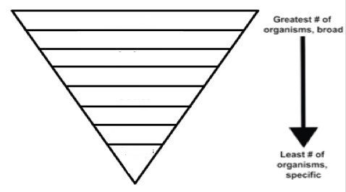 **K**_______________________________________________________________

**P**_______________________________________________________________

**C**_______________________________________________________________

**O**_______________________________________________________________

**F**_______________________________________________________________

**G**_______________________________________________________________

**S**_______________________________________________________________

Name___________________________________________ Period__________ Date___________

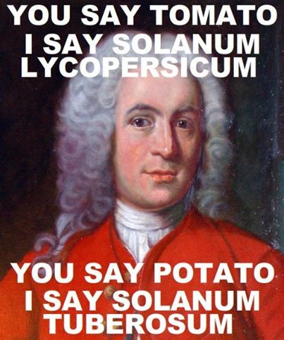 Fix this using the rules of Binomial Nomenclature!

Write the scientific name for 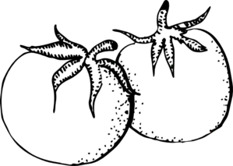 (Tomato)

Write the scientific name for  (Potato)

______________________________________________________________

1. **Differentiating between genus and species**; *Place all of the genus classification levels in the left box and all of the species classification levels in the right box.*

*pneumoniae*

*Staphylococcus*

*pyogenes*

*coli*

*Escherichia*

*Streptococcus*

*chrysogenum*

*Penicillium*

**Genus**

**Species**

1. How do you know the difference between genus and species?

1. Which classification level is MORE specific and LESS broad?

1. **Practice Writing Scientific Names**

*Change the following names to make them scientifically correct according to the* ***binomial nomenclature rules.***

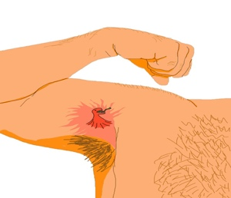

1. staphylococcus epidermis: *____________________________________*

*Kingdom: Monera (Bacteria)*

*Common name: “Staph Infection”*

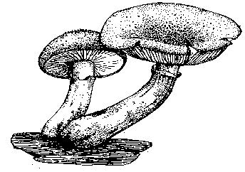

1. Armillaria Ostoyae: *__________________________________________*

*Kingdom: Fungi*

*Common name: “Honey Mushroom”*

**

1. Helianthus annuus: *______________________________________*

*Kingdom: Plant*

*Common name: “Sunflower”*

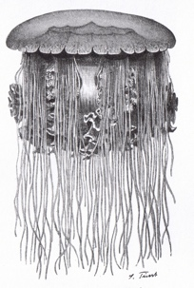

1. cyanea capillata: *___________________________________________*

*Kingdom: Animal*

*Common name: “Hair Jelly Fish” “Lion’s Mane Jellyfish”*

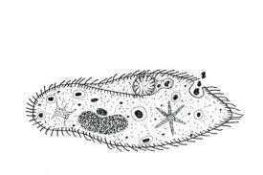

1. PARAMECIUM caudatum:*________________________________________*

*Kingdom: Protista*

*Common name: “Paramecium”*

Name_____________________________ Period__________ Date___________________

**LE-A Classification Day 5 Quiz**

1. What is binomial nomenclature?

1. What are the 4 rules of binomial nomenclature?

1. Who is the father of Taxonomy?

1. Which level of classification is most SPECIFIC?

Name_____________________________ Period__________ Date___________________

**Binomial Nomenclature & Classification Sequencing HW**

Which groups are arranged in correct descending order according to a modern classification system?

1. kingdom, genus, phylum, species
2. phylum, kingdom, species, genus
3. kingdom, phylum, genus, species
4. phylum, genus, species, kingdom

In one modern classification system, organisms are grouped into five

1. kingdoms
2. phyla
3. genera
4. species

The scientific name for the fruit fly is Drosophila melanogaster. What classification group does the word Drosophila refers to?

1. Kingdom
2. Phylum
3. Genus
4. Species

In the binomial system of nomenclature, which two classification groups provide the scientific name of an organism?

1. kingdom and phylum
2. phylum and species
3. kingdom and genus
4. genus and species

Which classification category contains the greatest number of different types of organisms?

1. Kingdom
2. Phylum
3. Genus
4. species