Name_____________________________ Period__________ Date___________________
LE A Bell Work: Cell Theory
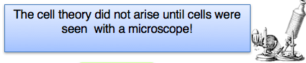
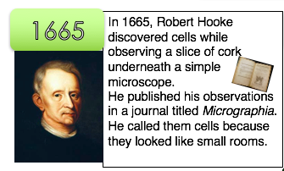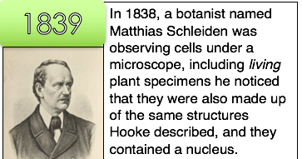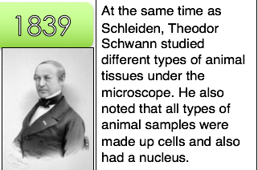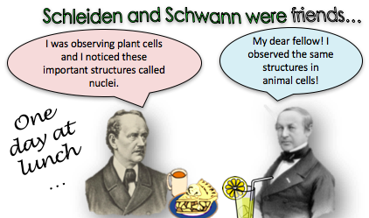
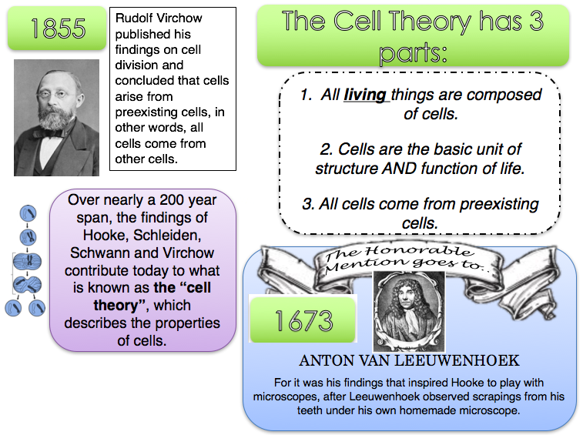

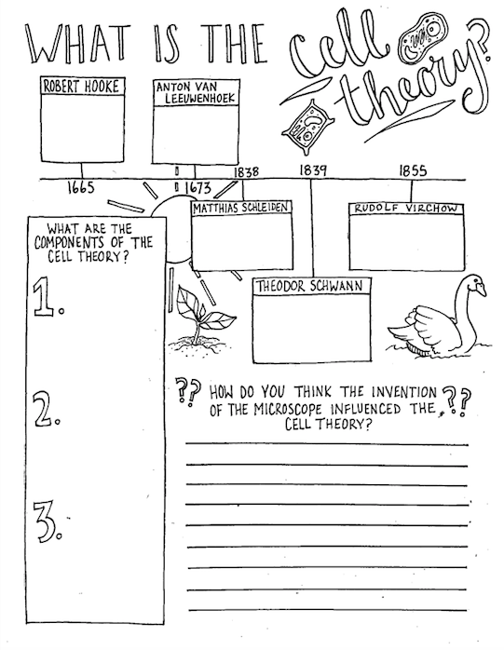

Name_____________________________ Period__________ Date___________________

LE A Cells Daily Quiz 1

1. How did microscopes impact the cell theory?
_____________________________________________________________________________
2.There are 3 parts of the cell theory, list one.
_____________________________________________________________________________
_____________________________________________________________________________
3.How were cells named (what did they look like to the scientist)?
_____________________________________________________________________________

4. What is an exception to the cell theory?
_____________________________________________________________________________

