Name___________________________ Period__________ Date___________________
LE-9R Cell Topic 3: Parts of a Cell
Many of the world’s organisms are made of only one cell, but all organisms from the most basic to the most complex are all made of cells. Cells are like a miniature city surrounded by a membrane that keeps the interior operating within its normal range (at homeostasis).

All of the cells organelles (little organs) are working with each other at all times to keep the balance.

Organelles have a large range of size, shape and function. Organelles are responsible for many jobs within a cell. Each organelle has its OWN job. Some jobs: protects the cell, controls the cell, power supplier of the cell, sort information and eliminate waste.

Questions
- Describe the role that each job has below.
Mayor Fireman
Police Sanitation
Trucking Construction
Power Plant Farmer
- What does the term organelle mean?
- Name 3 functions/jobs of organelles.

- List the levels of organization from most complex to least complex
Cell | Organ | Organism | Tissue | Organ System

Most complex Least Complex

1.____________2.________________3. ______________4. ______________5._______________

What are the organelles found in both plant and animal cells?
Diagram | Organelle | Function | Analogy
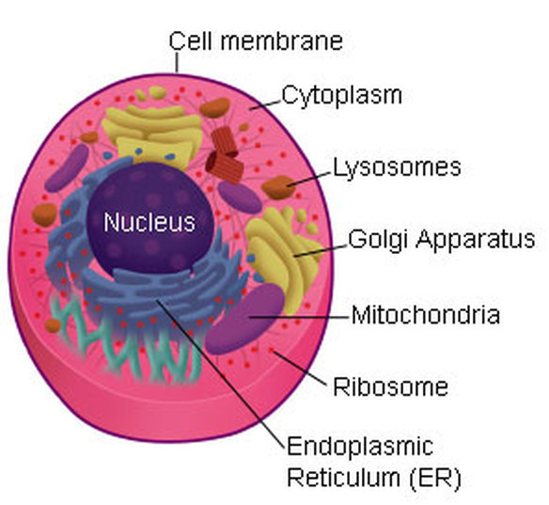 |  | Determines what goes in/out of the cell.  Protects and supports the cell.
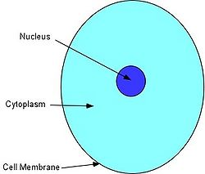 |  | The watery material in the cell between the cell membrane and the nucleus  Contains nutrients for cell.  Also for protection.a  The place where many chemical reactions occur
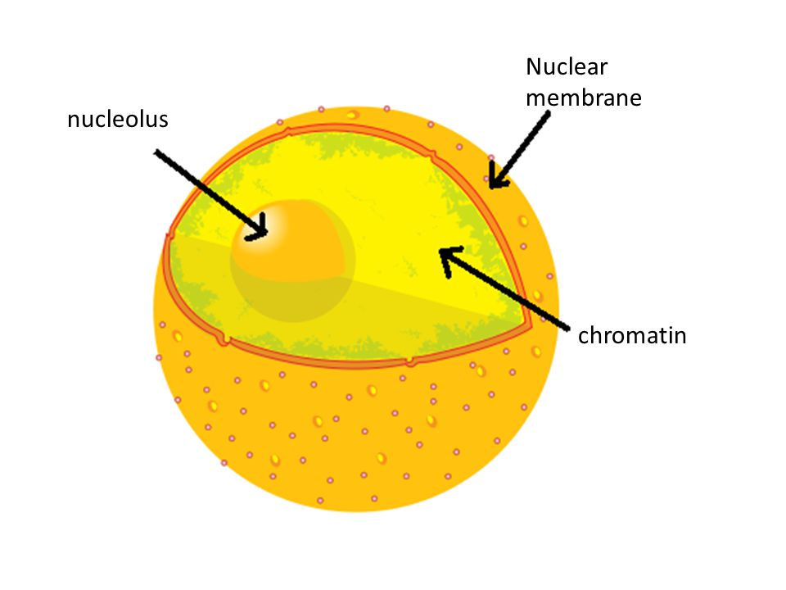 |  | Decides what goes into and out of the nucleus.
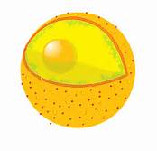 |  | Is the control center of the cell.  The “brain” of the cell.  Stores the genetic material of the cell, called DNA.

Name___________________________ Period__________ Date___________________
LE-9R Cells Daily Quiz 3
- What are organelles?

- Why is a cell like a city?

- Pick ONE organelle we learned today and explain its function: Cell membrane, Cytoplasm, Nuclear Membrane or Nucleus

