Name___________________________________________ Period__________ Date___________

**LE-9R Bell Work Topic: Naming & Sequence of Classification**

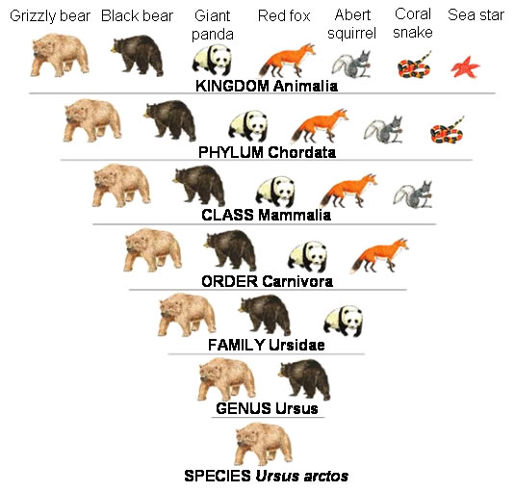We have already learned about the 5 kingdoms of life: Plants, Animals, Protista, Fungi and Monera (Bacteria). Kingdom is just ONE level of classification. Kingdom is the most **GENERAL** level of classification. Kingdom has the most amount of living things. There are several levels of classification that follow a SPECIFIC order that we will learn today. The image to the *right* shows the levels of classification. *Below* shows the order of the levels of classification.

Kingdom 🡺 Phylum 🡺 Class 🡺 Order 🡺 Family 🡺 Genus 🡺 Species

A man Carolus Linnaeus invented a naming system called: *binomial nomenclature*. This system helps scientists ORGANIZE and CLASSIFY organisms in science and all around the world. ALL scientists use this naming system.

1. Which level of classification is most GENERAL/ has the most amount of living things?  
   ________________________________________________________________________
2. What does binomial nomenclature help scientists do?  
   ________________________________________________________________________
3. Who uses the binomial nomenclature naming system?

________________________________________________________________________

IV: Binomial Nomenclature

* Definition: Two name classification system

Bi = ____________________________

Nomenclature = ___________________

* **Rules**:
  + - Must be in Latin
    - Must be in *italics* or underlined
    - Genus (1st word) must be capitalized
    - Species (2nd word) must be lowercase

**Practice Writing Scientific Names**

*Change the following names to make them scientifically correct according to the* ***binomial nomenclature rules.***

1. staphylococcus epidermis: *____________________________________*
2. Armillaria Ostoyae: *__________________________________________*
3. Helianthus annuus:

*______________________________________*

1. cyanea capillata: *___________________________________________*
2. PARAMECIUM caudatum:

*_______________________________*

V. Sequencing

Kingdom 🡺 Phylum 🡺 Class 🡺 Order 🡺 Family 🡺 Genus 🡺 Species

* Kingdom= Most GENERAL / Most amount of organism
* Species=

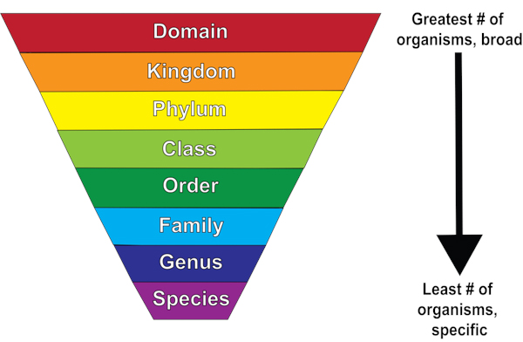

Name___________________________________________ Period__________ Date___________

**Practice Levels of Classification**

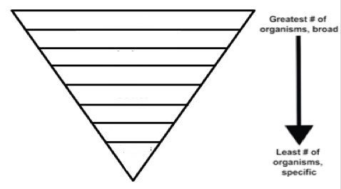 **K**_______________________________________________________________

**P**_______________________________________________________________

**C**_______________________________________________________________

**O**_______________________________________________________________

**F**_______________________________________________________________

**G**_______________________________________________________________

**S**_______________________________________________________________

Name_____________________________ Period__________ Date___________________

**LE-9R Classification Day 5 Quiz**

1. What is binomial nomenclature?

1. There are 4 rules of binomial nomenclature, list 2.

1. Identify below level of classification is most GENERAL?





Name_____________________________ Period__________ Date___________________

**Binomial Nomenclature & Classification Sequencing HW**

1. Which groups are arranged from GENERAL to SPECIFIC?
2. kingdom, genus, phylum, species
3. phylum, kingdom, species, genus
4. kingdom, phylum, genus, species
5. phylum, genus, species, kingdom
6. In one modern classification system, organisms are grouped into five
7. kingdoms
8. phyla
9. genera
10. species
11. Which classification category contains the greatest number of different types of organisms?
12. Kingdom
13. Phylum
14. Genus
15. species

*Change the following names to make them scientifically correct according to the* ***binomial nomenclature rules.***

1. PARAMECIUM caudatum
2. Homo Sapiens

_______________________________________________________________________________________