Name_____________________________ Period__________ Date___________________
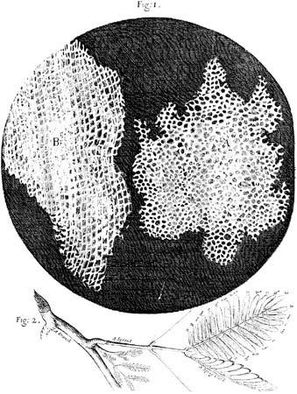
LE-9R Bell Work: Cell Theory

What is a cell?
A cell is made up of 3 important components which we now call the Cell Theory. A theory is an explanation of WHY something is or happens. The historical study of the cell started in 1665 when Robert Hooke becomes the first person to see cells; he was looking at cork and noted that he saw " great many boxes”. He descried these many boxes as looking like a monk’s “Living cell” (or a jail cell with rooms closely next to each other).

In 1673 Anton van Leeuwenhoek was the first person to see a living cell under a microscope. He observed living cells in pond water. These cells were Protista, such as amoeba, euglena and paramecium.
Because the microscope became more complex there were more discoveries were made.
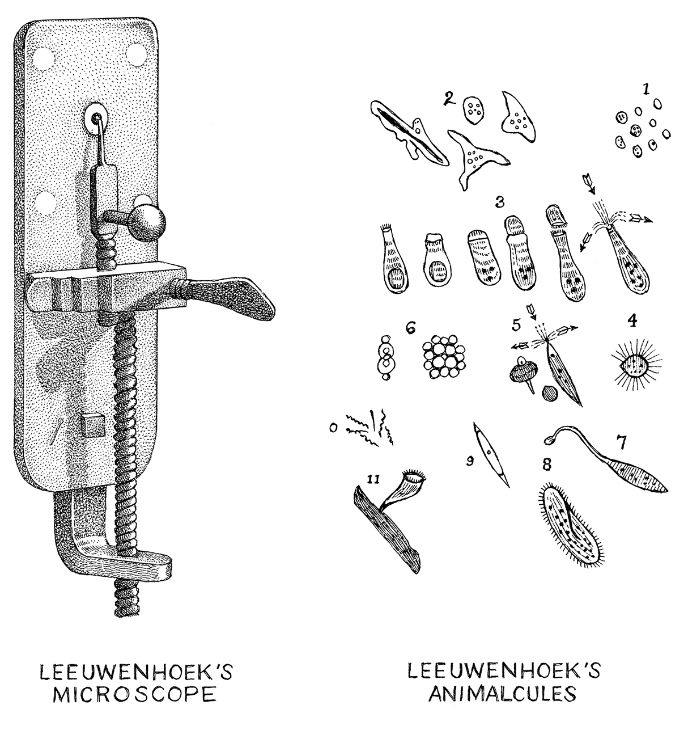
The cell theory states;
- Every living organism is made of one or more cells.
- The cell is the basic unit of structure and function.
- All cells arise from pre-existing cells.

Questions

1. What is a theory?
___________________________________________________________________________
2.Who was Robert Hooke?
_____________________________________________________________________________
3.Who was Anton van Leeuwenhoek?
_____________________________________________________________________________

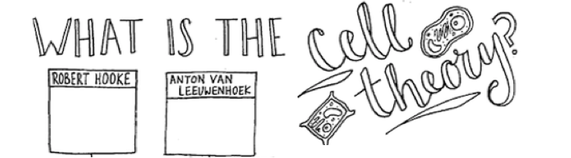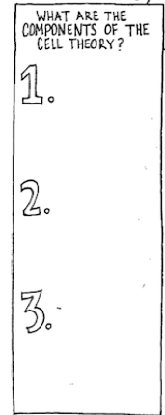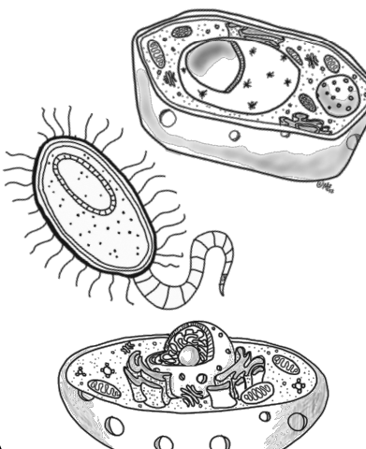
Exceptions to the Cell Theory
- The first cell did not come from a preexisting cell
- A virus is not living and is not made up of cells

Name_____________________________ Period__________ Date___________________

LE-9R Cells Daily Quiz 1

1. How did microscopes impact the cell theory?
_____________________________________________________________________________
2.There are 3 parts of the cell theory, list one.
_____________________________________________________________________________
_____________________________________________________________________________
3.How were cells named (what did they look like to the scientist)?
_____________________________________________________________________________

