Name_____________________________ Period__________ Date___________________

LE-9R Bell Work Topic: Classification

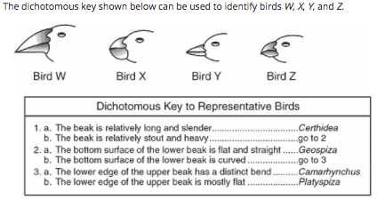
      - Bird X most likely falls under which classification?
        - Certhidea
        - Geospiza
        - Camarhynchus
        - Platyspiza

Kingdom Protista is often referred to as the “Junk Drawer Kingdom” simply because it includes a wide variety of eukaryotic organisms that do not fit into other Kingdoms. Many protists are unicellular, but some protists are multicellular. Some protists are heterotrophic, some are autotrophic, and some are both! Most live in water, but some can be found in in most soil or even the human body. As you can see, there are many characteristics of protists...the only thing they ALL have in common is the fact that they are EUKARYOTIC organisms.
Protists are classified based on two factors: how they obtain nutrition and how they move. These classification factors lead to two protist categories:
- Animal Like Protists (“Protozoans” or “First Animals) – Heterotrophs
- Plant Like Protists (“Algae”) – Autotrophs
The three we will be learning about in our class are Amoeba, Euglena and Paramecium.
- 2. Why are Protists considered the “Junk Drawer Kingdom”?
- _________________________________________________________________________

3.What are the 3 protists we will be learning about?
_________________________________________________________________________

- Protista
  - Number of cells: Unicellular
  - Cell type: Eukaryotic
  - Energy source: Heterotrophic or Autotrophic
    - Ingestion or absorption

Ex. Amoeba, Euglena and Paramecium

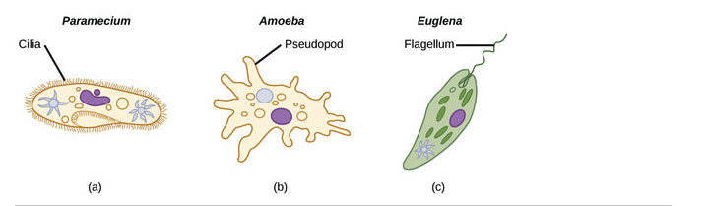

Paramecium
- Energy Source: Heterotrophic
- Mobility/ Locomotion: Cilia “Hair Like”
- Unique: Elongated & Oral groove

Amoeba
- Energy Source: Heterotrophic
- Mobility/ Locomotion: Pseudopod “False Feet”
- Unique: Food Vacuoles, Phagocytosis (Wraps around food)

Euglena
- Energy Source: Autotrophic
- Mobility/ Locomotion: Flagella ”Whip Like”
- Unique: Eye spot (Stigma), Pear Shaped, Whip like tail & Chlorophyll (Green Color)

Name_____________________________ Period__________ Date___________________
Protista Review
Word Bank: Terms are underlined and description is in italics.
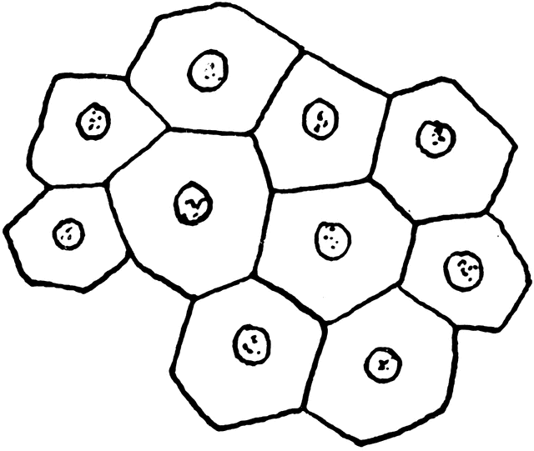  Multicellular | Unicellular | Has a Nucleus  (Eu=True Nucleus)  Eukaryotic | Lacks a Nucleus  (Pro=NO)  Prokaryote | Protects the DNA in a cell  Nucleus | Heterotrophic | Autotrophic
“Whip-Like”  Flagella | “Hair-Like”  Cilia | “False-Feet”  Pseudopod | Protists  ----------> | 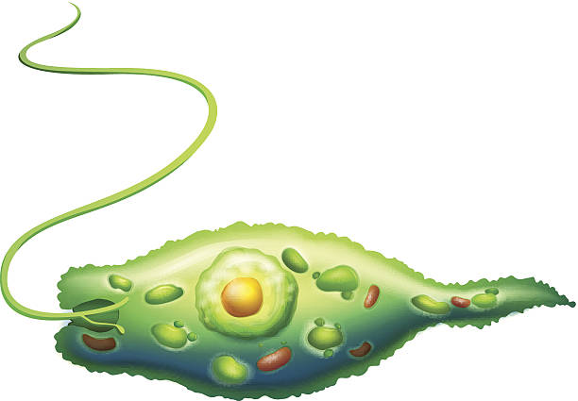  Euglena | 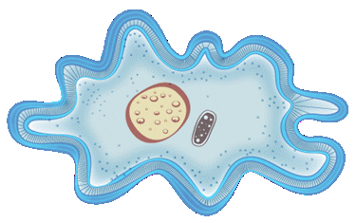  Amoeba | 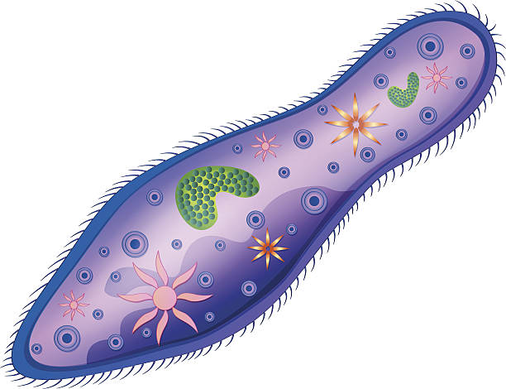  Paramecium

Use the word bank above and your class notes to complete the chart below.
Kingdom  & Organism | Cell Number  Unicellular/Multicellular | Cell Type  Prokaryote/Eukaryote | Energy Source  Autotrophic/Heterotrophic | Mobility/Locomotion  Flagella/Cilia/Pseudopod

Name_____________________________ Period__________ Date___________________

LE-9R Classification Day 3 Quiz

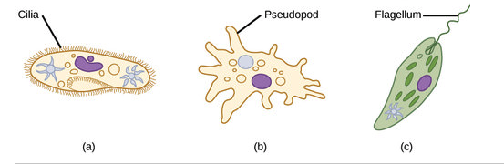

- What Kingdom do the above organisms ALL belong to?
________________________________________________________________________________________
- Which letter represents Euglena?
________________________________________________________________________________________
- Are the above organisms unicellular or multicellular?
________________________________________________________________________________________

- What is the nickname for this kingdom?
________________________________________________________________________________________

Name_____________________________ Period__________ Date___________________
Classification HW

1.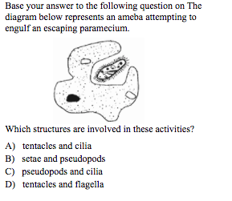2.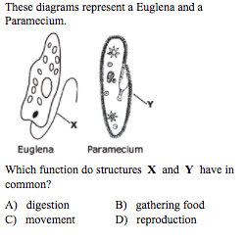

- 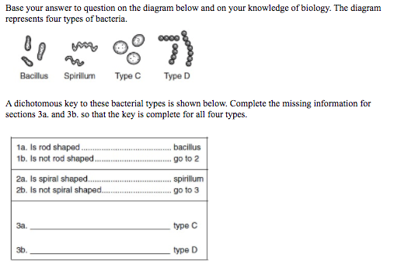

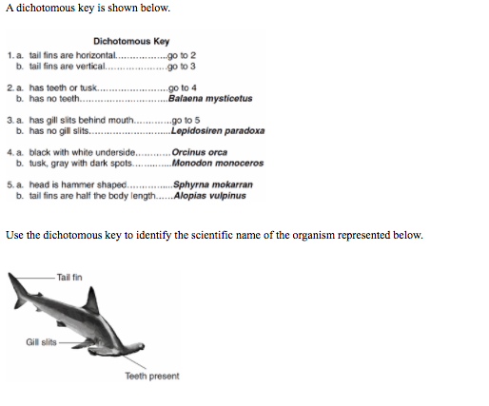

- Some species of algae are unicellular, motile, and photosynthetic. Under one modern system of classification, they would be classified as:
- Mollusks b. Fungi c. Protists d. Tracheophytes

- Use the image below to identify the structures used for mobility/ locomotion of the Protista.
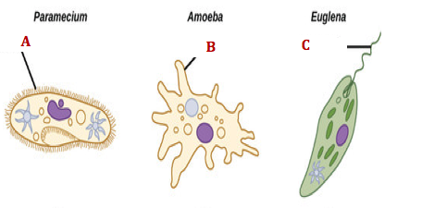
Label A____________________
Label B____________________
Label C____________________

