Name_____________________________ Period__________ Date___________________

Bell Work Topic: Classification
How are organisms grouped, sorted, and classified?
Why? From the time we begin to talk, we start to name things. We like to see how things are related. It is natural then, that biologists would name and organism into a classification system.
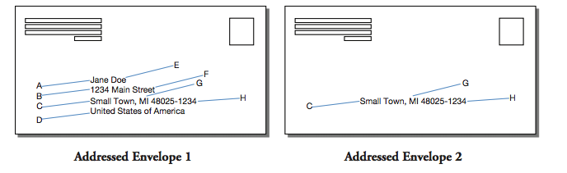
- According to the envelops above, who is supposed to receive the letter?
_______________________________________________________________________________________
- Decide with your partner which of the two letters will be more successful at reaching its destination. Justify your choice.
_______________________________________________________________________________________
- In Addressed Envelope 1, which four letters (A-H) correspond to the most specific part of the address?
_______________________________________________________________________________________
- In Addressed Envelop 1, which four letters (A-H) correspond to the most general part of the address?
_______________________________________________________________________________________
- In recent years, the United States Post Office has introduced a zip code plus 4 (H). Thinking about what you have just learned about address, why would this additional information be added to address labels?_________________________________________________________________________________________________________________________________________________________________

I.Topic: _________________________
Definition
- The science of naming and classifying organisms based on STRUCTURAL SIMILARITES and EVOLUTIONARY RELATIONSHIPS.
- Structural Similarities= Appearance/ Characteristics / What they look like
  - ____Birds have feathers
  - Vegetables have seeds

- Evolutionary = Common Ancestors Evolutionary Tree
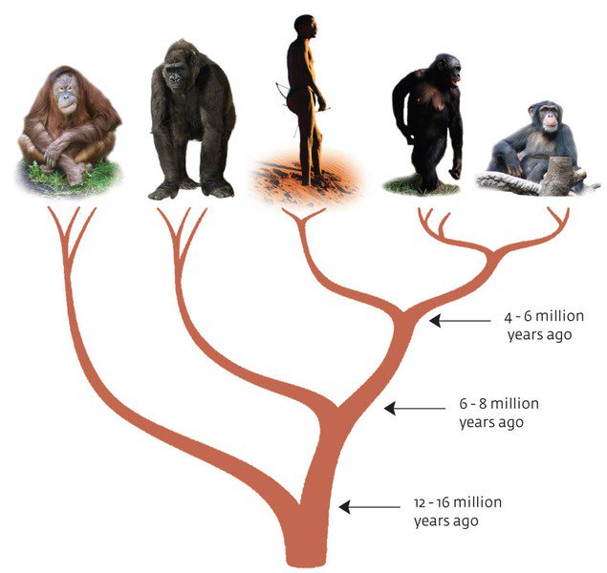

**Another word for Classification is ______________________**

II. Kingdoms

Define: Groups we organize all living things into.
- There are __________________ Kingdoms we classify all living things into.

II. Kingdoms

Define: Groups we organize all living things into.
- There are __________________ Kingdoms we classify all living things into.
- We classify things into kingdoms according to 3 things:
      - Cell type (prokaryote/eukaryote)​
      - Their ability to make food (autotroph/heterotroph)​
      - The number of cells in their body (unicellular/multicellular)
- Plants
- Number of cells: Multicellular
- Cell type: Eukaryotic
- Energy source: Autotrophic
  - Photosynthesis
Ex. Grass, Trees and Flowers

- Animals
  - Number of cells: Multicellular
  - Cell type: Eukaryotic
  - Energy source: Heterotrophic
    - Ingestion
Ex. Dog, Humans, Cat and Insects

- Protista
  - Number of cells: Unicellular
  - Cell type: Eukaryotic
  - Energy source: Heterotrophic or Autotrophic
    - Ingestion or absorption

Ex. Amoeba, Euglena and Paramecium

- Fungi
  - Number of cells: Multicellular
  - Cell type: Eukaryotic
  - Energy source: Heterotrophic
    - Absorption
Ex. Mushrooms, mold, yeast
- Monera
  - Number of cells: Unicellular
  - Cell type: Prokaryotic
  - Energy source: Heterotrophic or Autotrophic
    - Absorption
Ex. Bacteria (E.coli)

III. Dichotomous Key
Definition
- A tool that allows the user to determine the identity of items based on characteristic and traits.

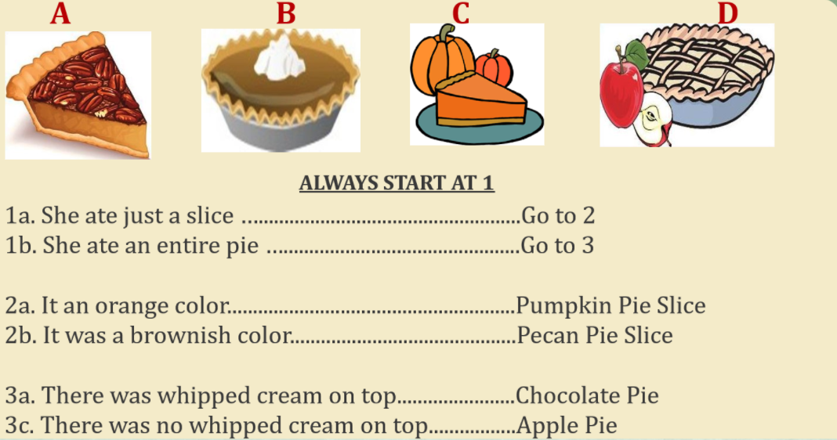

Name_____________________________ Period__________ Date___________________

Classification Day 1 Quiz

- What is the name of this topic?
______________________________________________________________________________________

- Define classification.
______________________________________________________________________________________________________________________________________________________________________________
- How many Kingdoms are there?
______________________________________________________________________________________

