Name_____________________________ Period__________ Date___________________

Bell Work Topic: Classification
Create two categories with the objects below
A : Toucan | 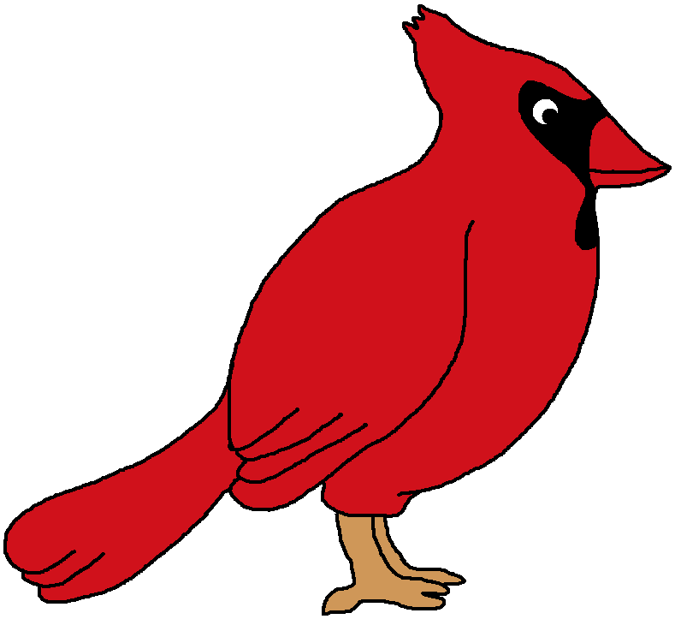  B: Cardinal | C: Corn | 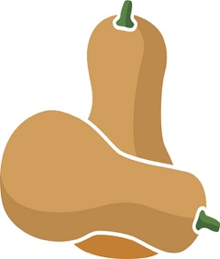  D: Squash | 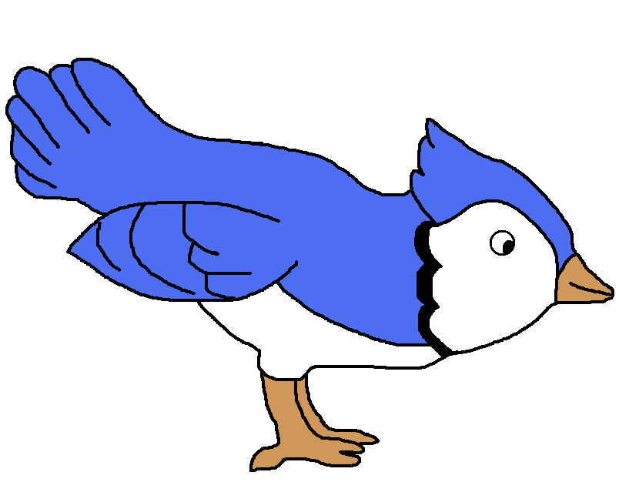  E: Blue Jay
F: Eggplant | 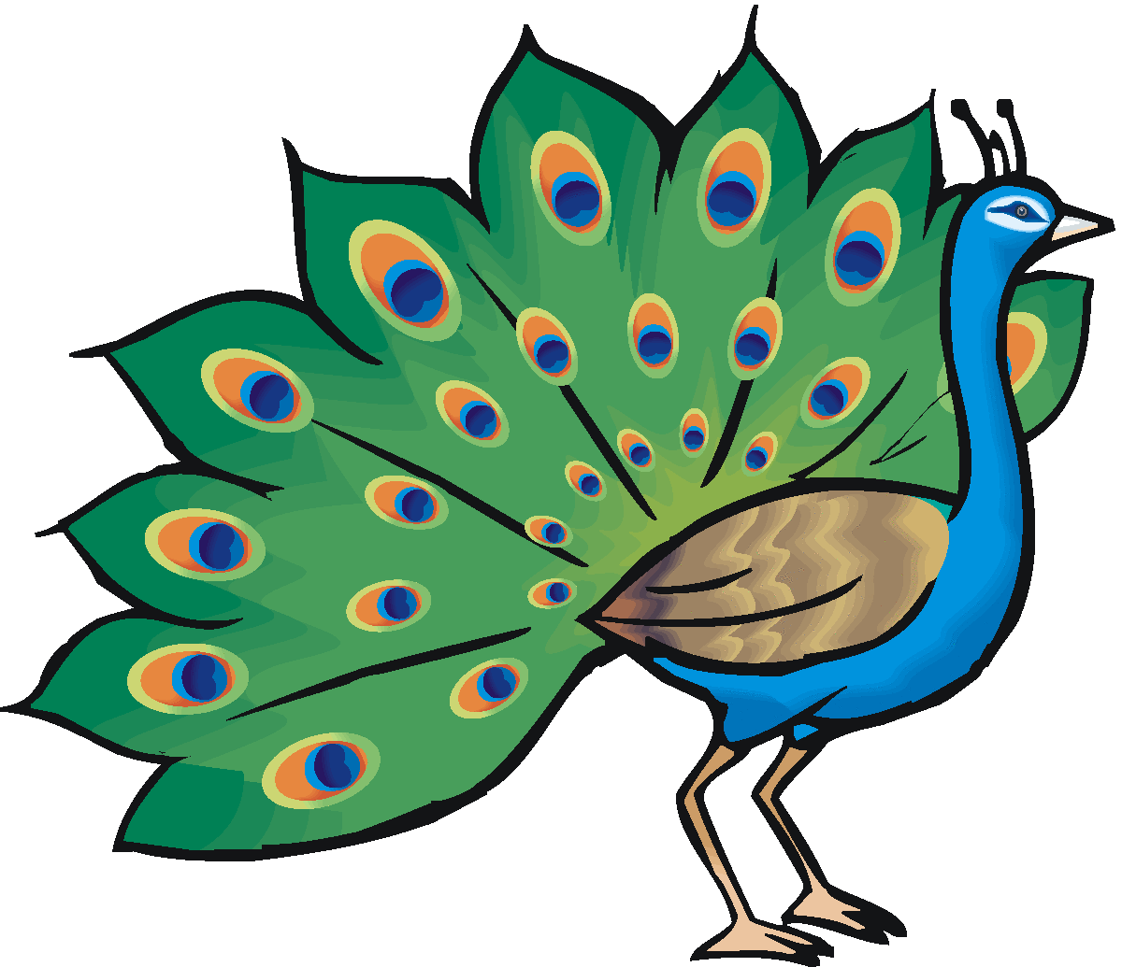  G: Peacock | 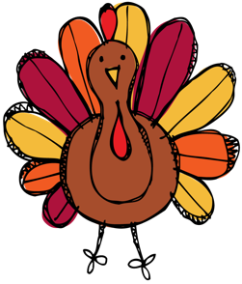  H: Turkey | I: Pumpkin | J: Sweet Potato

Group 1: | Group 2:
Object : __________________________  Object: __________________________  Object: __________________________  Object: __________________________  Object: __________________________ | Object : __________________________  Object: __________________________  Object: __________________________  Object: __________________________  Object: __________________________

- Explain how you classified the objects into two groups
________________________________________________________________________________
________________________________________________________________________________
________________________________________________________________________________

- Topic: _________________________
Definition

- The science of naming and classifying organisms based on STRUCTURAL SIMILARITES and EVOLUTIONARY RELATIONSHIPS.
- Structural Similarities= Appearance/ Characteristics / What they look like
  - ____Birds have feathers
  - Vegetables have seeds

- Evolutionary = Common Ancestors Evolutionary Tree
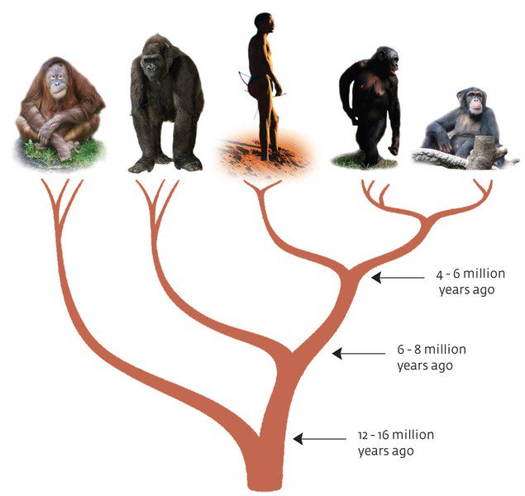

**Another word for Classification is ______________________**

II. Kingdoms
Define: Groups we organize all living things into.
- There are __________________ Kingdoms we classify all living things into.
II. Kingdoms
Define: Groups we organize all living things into.
- There are __________________ Kingdoms we classify all living things into.
- We classify things into kingdoms according to 3 things:
      - Cell type (prokaryote/eukaryote)​
      - Their ability to make food (autotroph/heterotroph)​
      - The number of cells in their body (unicellular/multicellular)
- Plants
- Number of cells: Multicellular
- Cell type: Eukaryotic
- Energy source: Autotrophic
  - Photosynthesis
Ex. Grass, Trees and Flowers

- Animals
  - Number of cells: Multicellular
  - Cell type: Eukaryotic
  - Energy source: Heterotrophic
    - Ingestion
Ex. Dog, Humans, Cat and Insects

- Protista
  - Number of cells: Unicellular
  - Cell type: Eukaryotic
  - Energy source: Heterotrophic or Autotrophic
    - Ingestion or absorption

Ex. Amoeba, Euglena and Paramecium

- Fungi
  - Number of cells: Multicellular
  - Cell type: Eukaryotic
  - Energy source: Heterotrophic
    - Absorption
Ex. Mushrooms, mold, yeast
- Monera
  - Number of cells: Unicellular
  - Cell type: Prokaryotic
  - Energy source: Heterotrophic or Autotrophic
    - Absorption
Ex. Bacteria (E.coli)

III. Dichotomous Key
Definition
- A tool that allows the user to determine the identity of items based on characteristic and traits.

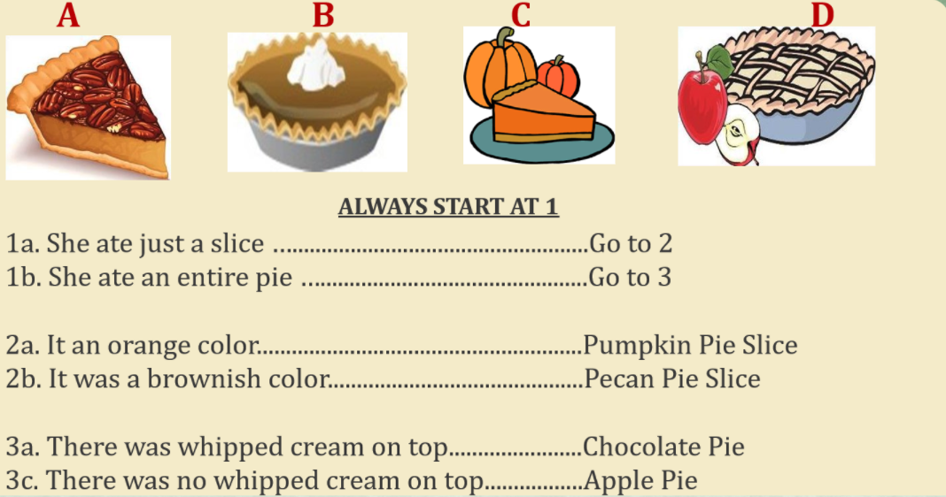

Name_____________________________ Period__________ Date___________________
Plants and Animals Review
Word Bank:
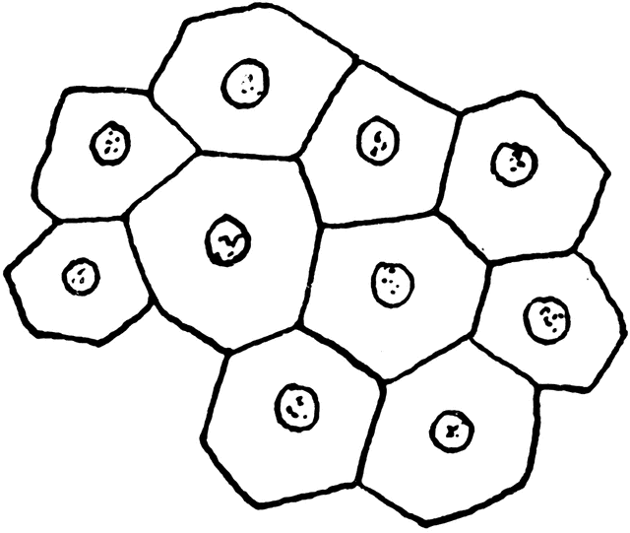  Multicellular | Unicellular | Has a Nucleus  Eukaryotic | Building blocks of all life  Cell | Protects the DNA in a cell  Nucleus | Heterotrophic | Autotrophic

Example Choices:
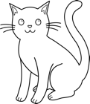  Cat | Flower | 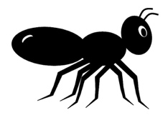  Ant | 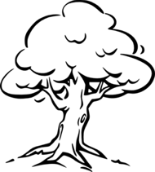  Tree | 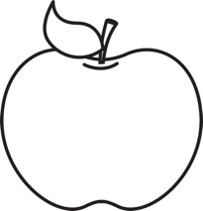  Apple | 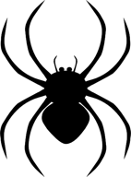  Spider | 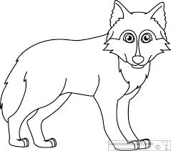  Wolf

Use the word bank above and your class notes to complete the chart below.
Kingdom | Cell Number  Multicellular/Unicellular | Cell Type  Prokaryote/Eukaryote | Energy Source  Autotrophic/heterotrophic | Examples
Plants
Animals

Name_____________________________ Period__________ Date___________________
Plants and Animals Homework
Complete the following table by filling in the boxes with the corresponding characteristics of each organism.
Organism | Cell Number  Multicellular/Unicellular | Cell Type  Prokaryote/Eukaryote | Energy Source  Autotrophic/heterotrophic | Kingdom  Plants/Animals
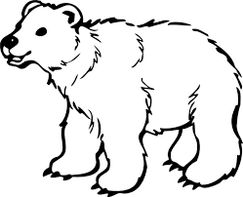
Bear
Leaf
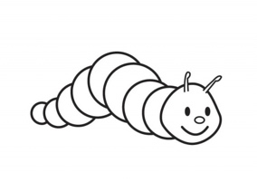
Caterpillar
Pumpkin
Apple
Spider
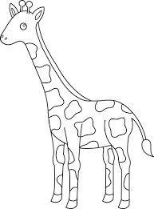
Giraffe

Name_____________________________ Period__________ Date___________________

Classification Day 1 Quiz

- What is the name of this topic?
__________________________________________________________________________

- Define classification.
____________________________________________________________________________________________________________________________________________________

- How many Kingdoms are there?
__________________________________________________________________________

- What is another word for classification?
__________________________________________________________________________

