Name_____________________________ Period__________ Date___________________
Plants and Animals Review
Word Bank: Terms are underlined and description is in italics.
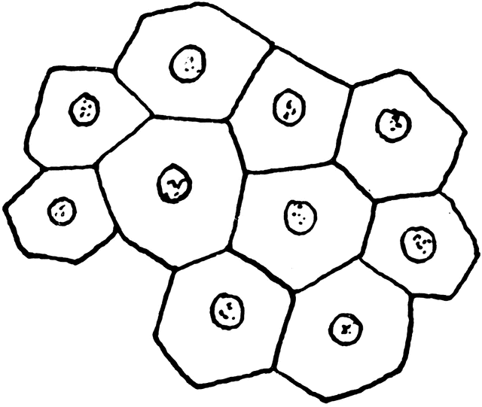  Multicellular | Unicellular | Has a Nucleus  (Eu=True Nucleus)  Eukaryotic | Lacks a Nucleus  (Pro=NO)  Prokaryote | Protects the DNA in a cell  Nucleus | Heterotrophic | Autotrophic
Example Choices:
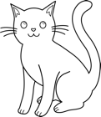  Cat | Flower | 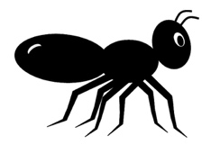  Ant | 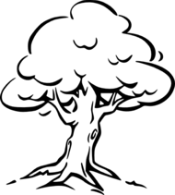  Tree | 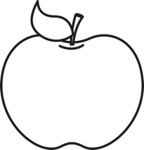  Apple | 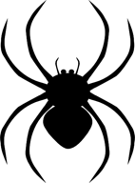  Spider | 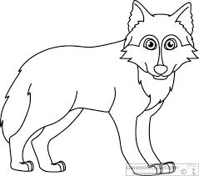  Wolf
Use the word bank above and your class notes to complete the chart below.
Kingdom | Cell Number  Multicellular/Unicellular | Cell Type  Prokaryote/Eukaryote | Energy Source  Autotrophic/heterotrophic | Examples
Plants
Animals

Name_____________________________ Period__________ Date___________________
Plants and Animals Homework
Complete the following table by filling in the boxes with the corresponding characteristics of each organism.
Organism | Cell Number  Multicellular/Unicellular | Cell Type  Prokaryote/Eukaryote | Energy Source  Autotrophic/heterotrophic | Kingdom  Plants/Animals
Bear
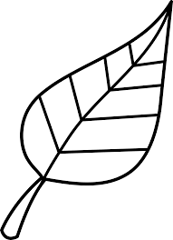
Leaf
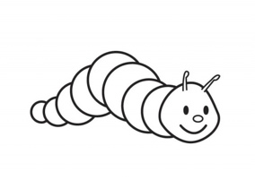
Caterpillar
Pumpkin
Apple
Spider
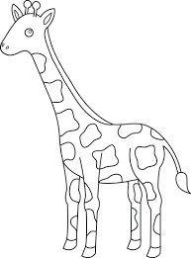
Giraffe

Name_____________________________ Period__________ Date___________________

LE-9R Classification Day 2 Quiz

- There are 3 ways we can classify an organism into kingdoms, list 1.
__________________________________________________________________________

- Is a plant unicellular or multicellular?
__________________________________________________________________________
- Is an animal autotropic or heterotrophic?

II. Kingdoms
Define: Groups we organize all living things into.
- There are __________________ Kingdoms we classify all living things into.
- We classify things into kingdoms according to 3 things:
      - Cell type (prokaryote/eukaryote)​
      - Energy Source Their ability to make food (autotroph/heterotroph)​
      - Cell Number # of cells in their body (unicellular/multicellular)

- Plants
- Number of cells: Multicellular
- Cell type: Eukaryotic
- Energy source: Autotrophic
  - Photosynthesis
Ex. Grass, Trees and Flowers
Your Notes:
  - ______________________________________________
  - ______________________________________________
  - ______________________________________________

- Animals
  - Number of cells: Multicellular
  - Cell type: Eukaryotic
  - Energy source: Heterotrophic
    - Ingestion
Ex. Dog, Humans, Cat and Insects

Your Notes:
  - ______________________________________________
  - ______________________________________________
  - ______________________________________________

- Protista
  - Number of cells: Unicellular
  - Cell type: Eukaryotic
  - Energy source: Heterotrophic or Autotrophic
    - Ingestion or absorption

Ex. Amoeba, Euglena and Paramecium
Your Notes:
  - ______________________________________________
  - ______________________________________________
  - ______________________________________________

- Fungi
  - Number of cells: Multicellular
  - Cell type: Eukaryotic
  - Energy source: Heterotrophic
    - Absorption
Ex. Mushrooms, mold, yeast
Your Notes:
  - ______________________________________________
  - ______________________________________________
  - ______________________________________________
- Monera
  - Number of cells: Unicellular
  - Cell type: Prokaryotic
  - Energy source: Heterotrophic or Autotrophic
    - Absorption
Ex. Bacteria (E.coli)
Your Notes:
  - ______________________________________________
  - ______________________________________________
  - ______________________________________________

III. Dichotomous Key
Definition
- A tool that allows the user to determine the identity of items based on characteristic and traits.

