Name_____________________________ Period__________ Date___________________

Bell Work Topic: Classification
Traditionally, living things were divided into two kingdoms, plants and animals. This was great for a long time. Some people still like to think of it that way. However, as our knowledge increases, and as the science of biology continues to develop, we have come to realize that two kingdoms are not enough for all organisms to fit into. Now that we know more about all sorts of strange creatures, most scientists agree that it makes sense to divide living things into five kingdoms. Remember, though, that kingdoms are purely human inventions. No other living organism, as far as we can tell, cares a bit what kingdom it is in. As the future of biology unfolds, we may see evidence for division into more than five kingdoms. (Various biologists have already suggested six, seven, and eight kingdoms.)

Kingdom Animalia (an-uh-MALE-ee-uh) Most members of this kingdom are familiar to you. Some may be kind of tricky though. Such things as sponges, sea anemones, sea cucumbers may not be as easily recognized, but are nonetheless still animals. All animals are multicellular. Animal cells lack a cell wall.
Animals are multicellular organisms. The cells of most animals are grouped together to form different kinds of tissue. Tissue may then combine to form an organ, which is a group of different tissues that work together to perform a specific job that is more complex than the function of each tissue by itself. Many organs then combine to form an organ system, such as the skeletal system. Most animals have highly developed brains and body systems. All animals are heterotrophs, and typically reproduce sexually. All animals require food, water, and oxygen to stay alive. In addition, all plants are eukaryotes. Eukaryote, any cell or organism that possesses a clearly defined nucleus. The eukaryotic cell has a nuclear membrane that surrounds the nucleus, in which the well-defined chromosomes (bodies containing the hereditary material) are located.

Kingdom Plantae (PLAN-tay) This includes plants (oddly enough!) So things like mosses, pine trees, and roses fit here. There’s also a bunch of algae in this kingdom. Plants are autotrophs that produce their own food. In addition, all plants are eukaryotes that contain many cells. Unlike other eukaryotes, however, plant cells have a cell wall. The cell wall is a boundary that surrounds the cell membrane and separates it from the environment. Plants are multicellular, with the same type of cells grouped into tissues.

- How many kingdoms did scientists initially divide organisms into?
________________________________________________________________________________

- What is the cell number for Animals (Multicellular/ Unicellular)?
________________________________________________________________________________

- What is the cell number for Plants (Multicellular/ Unicellular)?
________________________________________________________________________________

- What is a eukaryote?
________________________________________________________________________________

- If we know what a eukaryote is what would a prokaryote mean?
________________________________________________________________________________

- Above in our reading, what are the three way we identify animals and plants (hint: what’s bolded)?
_______________________________________________________________________________

- What makes animals different from plants?
_______________________________________________________________________________

Name_____________________________ Period__________ Date___________________
Plants and Animals Review
Word Bank: Terms are underlined and description is in italics.
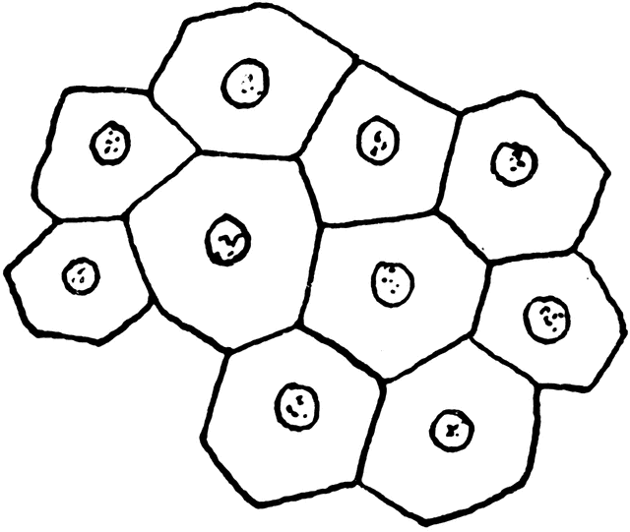  Multicellular | Unicellular | Has a Nucleus  (Eu=True Nucleus)  Eukaryotic | Lacks a Nucleus  (Pro=NO)  Prokaryote | Protects the DNA in a cell  Nucleus | Heterotrophic | Autotrophic
Example Choices:
Cat | Flower | 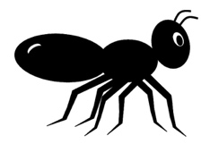  Ant | 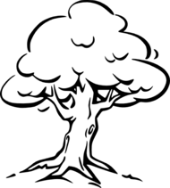  Tree | 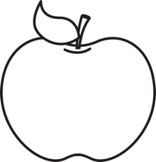  Apple | 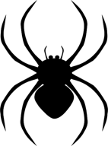  Spider | 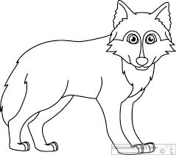  Wolf
Use the word bank above and your class notes to complete the chart below.
Kingdom | Cell Number  Multicellular/Unicellular | Cell Type  Prokaryote/Eukaryote | Energy Source  Autotrophic/heterotrophic | Examples
Plants
Animals

Name_____________________________ Period__________ Date___________________
Plants and Animals Homework
Complete the following table by filling in the boxes with the corresponding characteristics of each organism.
Organism | Cell Number  Multicellular/Unicellular | Cell Type  Prokaryote/Eukaryote | Energy Source  Autotrophic/heterotrophic | Kingdom  Plants/Animals
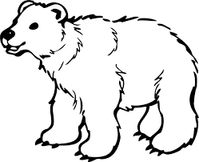
Bear
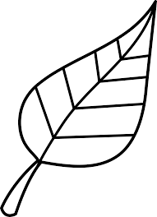
Leaf
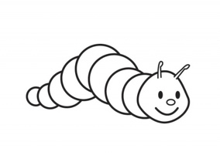
Caterpillar
Pumpkin
Apple
Spider
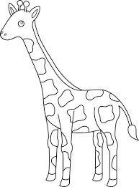
Giraffe

Name_____________________________ Period__________ Date___________________

Classification Day 2 Quiz

- What are the 3 ways an organism is classified into a kingdom?
_____________________________________________________________________________________

- Is a plant unicellular or multicellular?
_______________________________________________________________________________________
- Is an animal autotropic or heterotrophic?
______________________________________________________________________________________

- What is a eukaryote?
______________________________________________________________________________________

