Name_________________ Period__________ Date___________________

Bell Work: Monera and Fungi

Monera
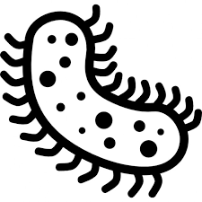
Monera include organisms such as BACTERIA. Monera cells do not have a nucleus (brain). They are called prokaryotes, which means “before a nucleus.” They are the only kingdom that lacks a nucleus. They also don’t have any organelles (“little organs”) to help with life processes. Monera are the simplest kinds of organisms. They have only one cell (single-celled organism). Some Monera are producers. Others are consumers. Monera= Bacteria

- What is a prokaryote cell type?
________________________________________________________________________
- What kingdom is bacteria located in? _______________________________________________________________________

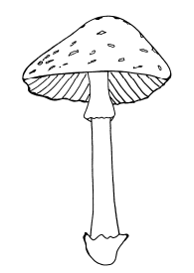
Fungi
Fungi isn’t a plant or an animal. Fungi have their own KINGDOM. Fungi do not make their own food, they are heterotrophic. Fungi absorb the nutrients around them. Most fungi are multicellular. Fungi include mushrooms, mold and yeast. Some fungi are used to make medicine. Others help recycle nutrients in the soil by decomposing material around them. We also can eat and drink fungi, but not all because some are toxic.

- Are fungi unicellular or multicellular?
__________________________________________________________________
- What are some examples of fungi?
__________________________________________________________________
- Can fungi produce their own food?

II. Kingdoms

- Fungi
  - Number of cells: Multicellular

  - Cell type: Eukaryotic

  - Energy source: ___________________________
    - Absorption
Ex. Mushrooms, mold, yeast

- Monera
  - Number of cells: __________________________

  - Cell type: Unicellular

  - Energy source: Heterotrophic or Autotrophic
    - Absorption
Ex. Bacteria (E.coli)

The Five Kingdoms of Life Review
Word Bank: Terms are underlined and description is in italics.
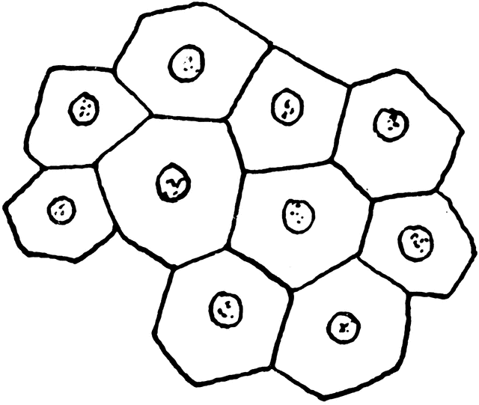  Multicellular | Unicellular | Has a Nucleus  (Eu=True Nucleus)  Eukaryotic | Lacks a Nucleus  (Pro=NO)  Prokaryote | Heterotrophic | Autotrophic | Kingdom  Monera
Kingdom  Protists  ----------> | Protista  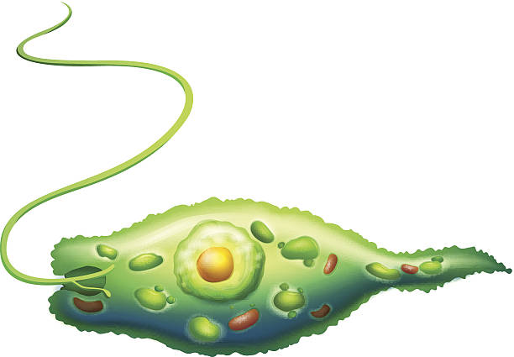  Euglena | Protista  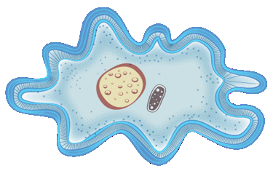  Amoeba | Protista  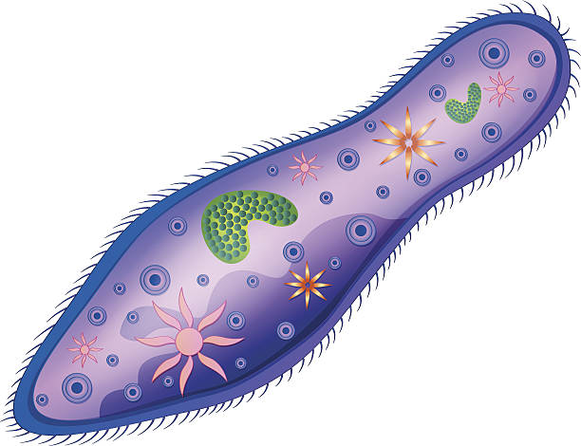  Paramecium | Kingdom  Animals | Kingdom  Plants | Kingdom  Fungi
Movement  Locomotion  ----------> | “Whip-Like”  Flagella | “Hair-Like”  Cilia | “False-Feet”  Pseudopod
Use the word bank above and your class notes to complete the chart below.
Organism | Cell Type  Prokaryote/Eukaryote | Cell Number  Unicellular/Multicellular | Energy Source  Autotroph/Heterotroph | Kingdom
Mushroom
Tree
Bacteria
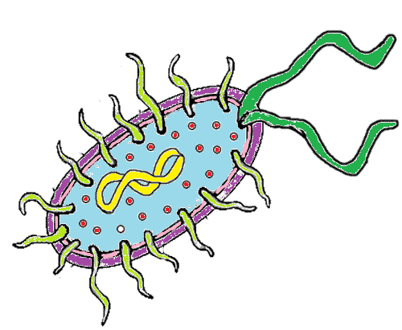
Paramecium
Locomotion:

Frog
Euglena
Locomotion:

Amoeba
Locomotion:

Name_____________________________ Period__________ Date___________________

LE Classification Day 4 Quiz

- What is a prokaryote cell type?
________________________________________________________________________
- What kingdom is bacteria located in? _______________________________________________________________________
- Are fungi unicellular or multicellular?
_______________________________________________________________________
- What are some examples of fungi?
_______________________________________________________________________
- Can fungi produce their own food?

- Are all bacterial hurtful to humans?
_______________________________________________________________________

Name_________________ Period__________ Date___________________

The Five Kingdoms of Life Review

- What are the unicellular kingdoms?

- What is the only prokaryotic kingdom?

What is the locomotion of Euglena?

What is the locomotion of Paramecium?

What is the locomotion of Amoeba?

- Why is fungi NOT considered a plant?

- What is the process by which plants make their own food?

- What does the Monera Kingdom LACK/ DO NOT HAVE?

- What are the 5 Kingdoms of Life which we classify ALL living organisms into?

10.What’s another word for classification?

Name_________________ Period__________ Date___________________

The Five Kingdoms of Life Homework

Using the information we have learned about Protista. Draw all three in the chart below. Include how they move around.
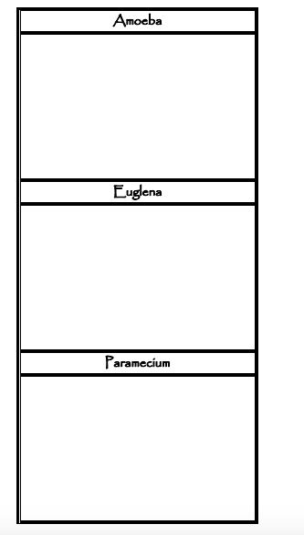
Name_________________ Period__________ Date___________________

The Five Kingdoms of Life Homework

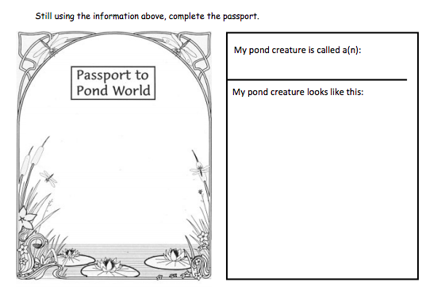

CIRCLE below the correct choice for your Protista of choice:

- My protista moves using it’s Flagella/Cilia/Pseudopods.

- My protista obtains food/energy autotrophically/heterotrophically.

- My protista is unicellular/multicellular.

